UNITED METHODIST CHURCH OF CADILLAC
REV. EARL DETWILER
SUNDAY, OCTOBER 4, 2026

PRELUDE

BRINGING IN THE LIGHT OF CHRIST

GREETING AND ANNOUNCEMENTS

WITH FAITH, ENTER INTO GOD’S DIVINE PRESENCE

*CALL TO WORSHIP TFWS 2016
“Glorify Thy Name”

*HYMN OF PRAISE UMH 618
“Let Us Break Bread Together”

*UNISON OPENING PRAYER
Lord, you know how hard I worked for my possessions. At times I got ahead and other times I struggled to make ends meet. I let those events get to me, Lord. If the days in the month were longer than the dollars in the bank, I really lost it. When finances worked out, I tried not to boast too much, but honestly, finances have a huge hold on my life. Help me, dear Lord, to put all of life into perspective and gain that assurance from you that leads to peace deep in my heart. In Jesus’ name. AMEN

BY FAITH, WE LOOK INSIDE OUR LIVES

CALL TO REFLECTION UMH 881
“The Apostle’s Creed”

A MOMENT FOR SILENCE

BY FAITH, WE SHARE IN THE WORD OF GOD

CHOIR ANTHEM Chancel Choir
“Lord, I Know I’ve Been Changed”
Arr. David Angerman & Michael Barrett

SCRIPTURE READING Matthew 21:33-46

SERMON Pastor Earl Detwiler
“Tenants or Owners?”

BY FAITH, WE RESPOND TO GOD’S CALL

HYMN OF RESPONSE TFWS 2108
“O How He Loves You and Me”

SERVICE OF HOLY COMMUNION
(You may bring your offering forward with you and place it in the offering plate.)

*Doxology UMH 95
“Praise God, From Whom All Blessings Flow”

MINISTRY OF PRAYER
Sharing our Joys and Concerns
Pastoral Prayer
The Lord’s Prayer
Our Father, who art in heaven, hallowed be thy name. Thy kingdom come, thy will be done on earth as it is in heaven. Give us this day our daily bread. And forgive us our trespasses, as we forgive those who trespass against us. And lead us not into temptation but deliver us from evil. For thine is the kingdom, and the power, and the glory forever. Amen.

BLESSING OUR GIFTS TO GOD

*Prayer Of Dedication

WE GO FORTH TO SERVE

*CLOSING HYMN TFWS 2158
“Just a Closer Walk with Thee”

*BENEDICTION

*POSTLUDE

United Methodist Church
of Cadillac
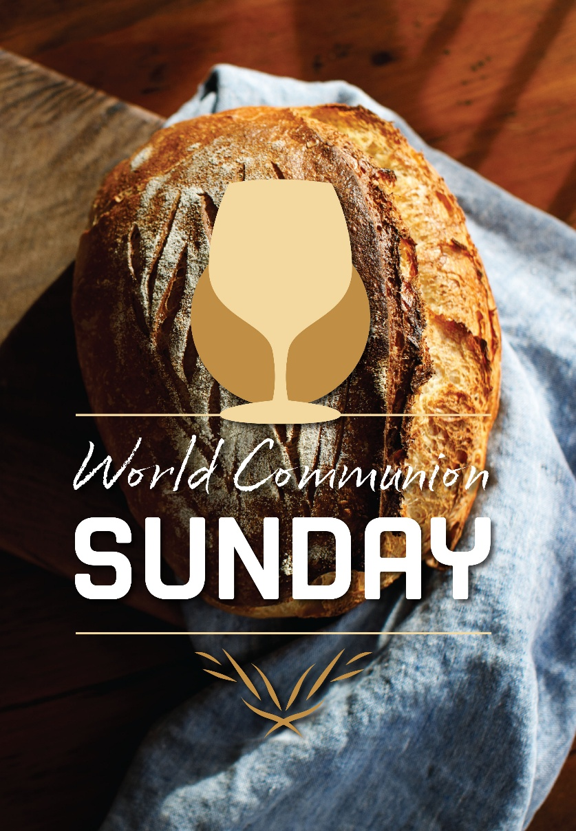

Sunday, October 4, 2026

