UNITED METHODIST CHURCH OF CADILLAC
REV. EARL DETWILER
SUNDAY, OCTOBER 18, 2026

PRELUDE

BRINGING IN THE LIGHT OF CHRIST

GREETING AND ANNOUNCEMENTS

WITH FAITH, ENTER INTO GOD’S DIVINE PRESENCE

*CALL TO WORSHIP UMH 393
“Spirit of the Living God”

*HYMN OF PRAISE UMH 133
“Leaning on the Everlasting Arms”

*UNISON OPENING PRAYER
The colors are amazing! God, your paintbrush is filled with the right colors and hues. During this time of the year, you are reminding us of your constant presence that turns the sweltering days of summer into bright and vibrant colors of fall. Are you trying to tell us something? Are you demonstrating exactly what you did for Jesus? He went through rough times but three days later. Victory! As the late Robert Schuller said, “Tough times don’t last, Tough people do.” Help us, Lord to be that tough, in Jesus’ name AMEN

BY FAITH, WE LOOK INSIDE OUR LIVES

CALL TO REFLECTION UMH 887
“Affirmation of Romans 8”

A MOMENT FOR SILENCE

BY FAITH, WE SHARE IN THE WORD OF GOD

CHORAL ANTHEM Chancel Choir
“Oh, for a Thousand Tongues to Sing” Arr. David Crowder

SCRIPTURE READING Luke 4:14-21

SERMON Pastor Earl Detwiler
“Victory Lap”

BY FAITH, WE RESPOND TO GOD’S CALL

HYMN OF RESPONSE UMH 191
“Jesus Loves Me”

MINISTRY OF PRAYER
Sharing our Joys and Concerns
Pastoral Prayer
The Lord’s Prayer
Our Father, who art in heaven, hallowed be thy name. Thy kingdom come, thy will be done on earth as it is in heaven. Give us this day our daily bread. And forgive us our trespasses, as we forgive those who trespass against us. And lead us not into temptation but deliver us from evil. For thine is the kingdom, and the power, and the glory forever. Amen.

BLESSING OUR GIFTS TO GOD
Offertory

*Doxology UMH 95
“Praise God, From Whom All Blessings Flow”

* Prayer of Dedication

WE GO FORTH TO SERVE

*CLOSING HYMN UMH 370
“Victory in Jesus”

*BENEDICTION

*POSTLUDE

United Methodist Church
of Cadillac
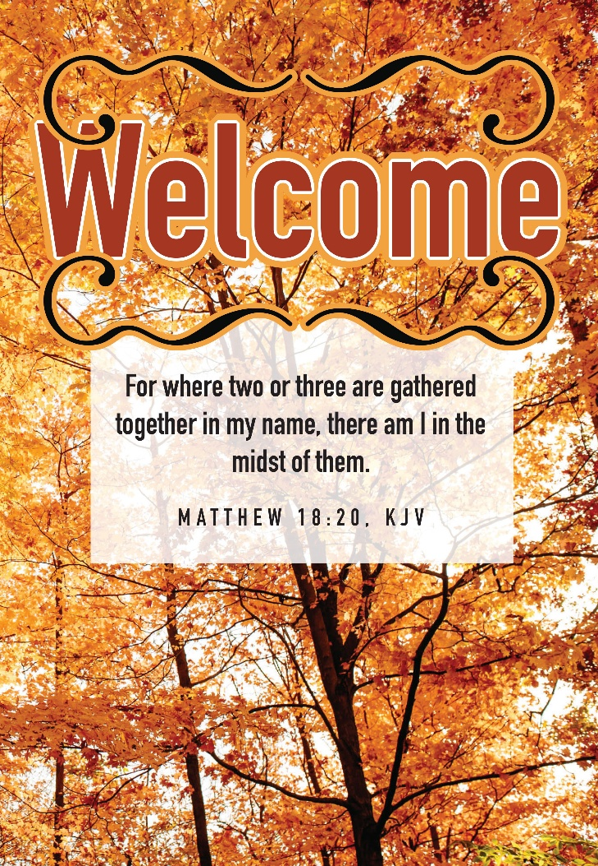
October 18, 2026

