UNITED METHODIST CHURCH OF CADILLAC
REV. EARL DETWILER
SUNDAY, OCTOBER 11, 2026

PRELUDE

BRINGING IN THE LIGHT OF CHRIST

GREETING AND ANNOUNCEMENTS

THE PUPPETS ARE HERE!

WITH FAITH, ENTER INTO GOD’S DIVINE PRESENCE

*CALL TO WORSHIP UMH 404
“Every Time I Feel the Spirit”

*HYMN OF PRAISE UMH 733
“Marching to Zion”

*UNISON OPENING PRAYER
O, Lord, what beautiful weather! Clearly, you have put a chill in the air and the trees are responding. The colors are glorious and vibrant. That also means that seasons are changing. There are times I don’t like to embrace changes. Changes mean life unfolds differently and I like it just where I am. Yet, everything around me shows change. How do I come to a clear understanding? Touch me, O Lord! In Jesus’ name. AMEN

BY FAITH, WE LOOK INSIDE OUR LIVES

CALL TO REFLECTION UMH 882
“The Ecumenical Apostles’ Creed”

A MOMENT FOR SILENCE

BY FAITH, WE SHARE IN THE WORD OF GOD

SPECIAL MUSIC Clarinet & Flute Duet
“It Is Well” by Phillip Bliss ~ Arr. John Jay Hilfiger

SCRIPTURE READING Matthew 22:1-14

SERMON Pastor Earl Detwiler
“Puttin’ on the Ritz”

BY FAITH, WE RESPOND TO GOD’S CALL

HYMN OF RESPONSE UMH 347
“Spirit Song”

MINISTRY OF PRAYER
Sharing our Joys and Concerns
Pastoral Prayer
The Lord’s Prayer
Our Father, who art in heaven, hallowed be thy name. Thy kingdom come, thy will be done on earth as it is in heaven. Give us this day our daily bread. And forgive us our trespasses, as we forgive those who trespass against us. And lead us not into temptation but deliver us from evil. For thine is the kingdom, and the power, and the glory forever. Amen.

BLESSING OUR GIFTS TO GOD
Offertory

*Doxology UMH 95
“Praise God, From Whom All Blessings Flow”

* Prayer of Dedication

WE GO FORTH TO SERVE

*CLOSING HYMN UMH 572
“Pass It On”

*BENEDICTION

*POSTLUDE

***************************************************************
Thank you to
Ruth Boonzaaijer Selby and Chris Selby
for providing our
Special Music this morning.

United Methodist Church
of Cadillac
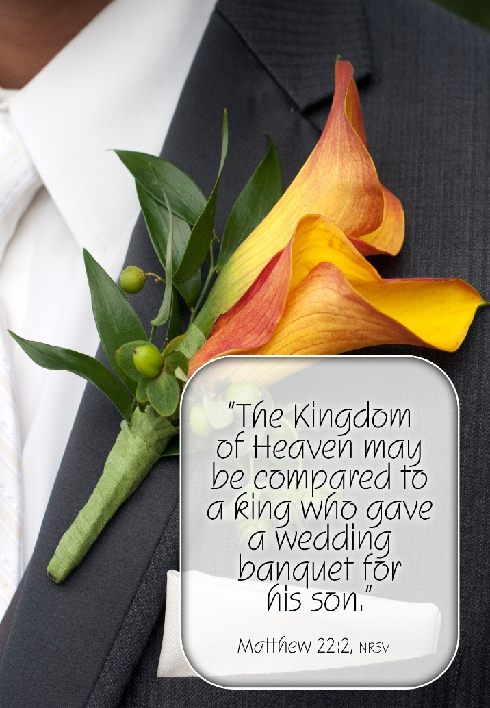

October 11, 2026

