UNITED METHODIST CHURCH OF CADILLAC
REV. EARL DETWILER
SUNDAY, NOVEMBER 1, 2026

PRELUDE

BRINGING IN THE LIGHT OF CHRIST

GREETING AND ANNOUNCEMENTS

WITH FAITH, ENTER INTO GOD’S DIVINE PRESENCE

*CALL TO WORSHIP UMH 405
“Seek Ye First”

*OPENING HYMN UMH 710
“Faith of Our Fathers”

*UNISON OPENING PRAYER
How important is our memory! We can remember where the pitfalls are located and avoid them. We can remember difficult outcomes and avoid them. So much of life is put into perspective by our memory. O Lord, help us to protect our memory from evil condemnation. Help us to use it constructively to forgive and respect. Help us to constantly check our memory with your Word. Help us to use our memory through the power of the Spirit. Yes, Lord, may we turn over our memory to your love and grace in Jesus’ name. AMEN

BY FAITH, WE LOOK INSIDE OUR LIVES

CALL TO REFLECTION
COMMUNION OF THE SAINTS, IN REMEMBRANCE UMH 711
“For All the Saints”
Tom Bihlmeyer (congregation sings verse 1) candle lighting
Bob Peterson (congregation sings verse 6) candle lighting

A MOMENT FOR SILENCE

BY FAITH, WE SHARE IN THE WORD OF GOD

CHOIR ANTHEM Chancel Choir
“Come Find Forgiveness and Love” by Don Besig

SCRIPTURE READING Matthew 22:34-46

SERMON Pastor Earl Detwiler
“Greatest Therapist”

BY FAITH, WE RESPOND TO GOD’S CALL

HYMN OF RESPONSE UMH 393
“Spirit of the Living God”

HOLY COMMUNION, IN REMMEMBRANCE OF CHRIST
*Doxology UMH 95
“Praise God, From Whom All Blessings Flow”

MINISTRY OF PRAYER
Sharing our Joys and Concerns
Pastoral Prayer
The Lord’s Prayer
Our Father, who art in heaven, hallowed be thy name. Thy kingdom come, thy will be done on earth as it is in heaven. Give us this day our daily bread. And forgive us our trespasses, as we forgive those who trespass against us. And lead us not into temptation but deliver us from evil. For thine is the kingdom, and the power, and the glory forever. Amen.

BLESSING OUR GIFTS TO GOD
Offertory
*Prayer of Dedication

WE GO FORTH TO SERVE

*CLOSING HYMN UMH 717
“Battle Hymn of the Republic”
*BENEDICTION

*POSTLUDE

UNITED METHODIST CHURCH
OF CADILLAC

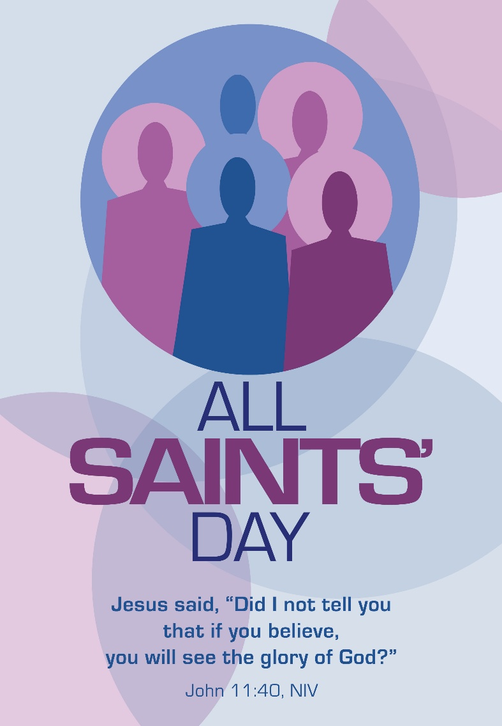

November 1, 2026

