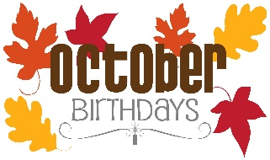
Upcoming Birthdays
October 8 – Art VanderHart
October 9 - Jacki Bailey, Addie Bailey
October 12 – Nick Nelson
October 16 – Patti Bovee

Pastor Earl Detwiler
Email: broffermoon@gmail.com
Phone: 785.213.1886
Prayer Requests (email): umccadillac@gmail.com
Church Website: www.cadillacumc.org
Church Email: umccadillac@gmail.com
Church Mailing Address: PO Box 37, Cadillac, MI 49601
Phone: (231) 775.5362
Office Hours: Monday - Thursday 10:00 a.m. - 4:00 p.m.
Pastor Earl’s Office Hours: Monday – Thursday 9:30 am – 1:00 pm
Closed on Fridays

Volunteer Ministry for Sunday, October 11, 2026
Organist/Pianist: Ruth Boonzaaijer
Liturgist: Yvonne Bandelow
Ushers/Greeters: Jack Davis, Dee Brinks, MJ VanderHart
3 dozen cookies (each) for Coffee Hour: Bob & Beth Garner, Open
____________________________________________________________
CHURCH STAFF
Pastor: Rev. Earl Detwiler
Office Manager: Diane Coon
Treasurer: Sara Austin
Choir Director: Megan Leineke
Organists/Pianists: Ruth Boonzaaijer, Megan Leineke, Skip Pluger,
Dr. Glenn Verbrugge
Nursery: Diana VanAntwerp

What’s Happening at Church This Week………
Sunday, October 4 – World Communion Sunday
10:30 a.m. – Worship Service w/Holy Communion

Monday, October 5
11:00 a.m. – 5:00 p.m. – Red Cross Blood Drive in FH
3:00 p.m. – Prayer Group in Wesley Room
6:30 p.m. – Freedom Festival Board Meeting in Corbin Room
7:00 p.m. - BSA Troop #125 in Fellowship Hall
Tuesday, October 6
11:00 a.m. – 5:00 p.m. – Red Cross Blood Drive in FH
Wednesday, October 7
10:30 a.m. – 12:30 p.m. – Weight Loss Group in Corbin Room
4:00 p.m. – Choir Practice
5:00 – 7:00 p.m. – Game Night in Fellowship Hall
7:00 p.m. – Alcoholics Anonymous in Corbin Room
Thursday, October 8
3:00 – 5:00 p.m. – Patriot Choir in Corbin Room
4:00 p.m. – Childrens Choir Practice in Sanctuary
4:00 – 7:00 p.m. – Project Christmas in Fellowship Hall
Friday, October 9 – Church Office Closed
8:00 p.m. – Alcoholics Anonymous in Corbin Room

Sunday, October 11
10:30 a.m. – Worship Service
4:00 p.m. – Annual Church Conference Hub @ Grant UMC

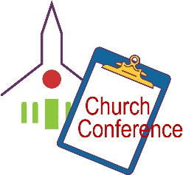

The Annual Church Conference Hub will be held at Grant UMC on Sunday, October 11 at 4:00 p.m.

We have openings on our 2026 Flower Chart for November 1 & 29 and December 6 & 20. Flowers on the altar is a nice way to honor an anniversary, birthday, or remember a loved one who is no longer with us. Flowers are only $15, and you can drop a check in the offering plate, marking in the memo line, “altar flowers.”

Our October Loose Plate Offering will go to Project Christmas. God bless you for your constant generosity with your financial support. Reminder: If you wish to write a check, please make the check out to UMC Cadillac, with a note on the check’s memo line that it is for October Loose Plate.

The food distribution for October will go to New Hope Shelter Food Pantry. They can use granola bars (urgent need), individually packaged snacks, coffee creamer, canned pasta, canned soups, toilet paper and paper towels. Please place your donations in the food storage container located between the double front doors. Thank you for your generosity.

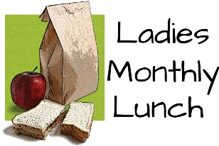
Mark your calendars for our next
Ladies Lunch!
Tuesday, October 13 @ Noon in
Fellowship Hall
(Men will meet same day and time in Corbin Room.)

Today’s Worship Ministry…………….
Organist/Pianist: Skip Pluger
Liturgist: Jeff Hinkston
Greeters/Ushers: Jack Davis, Diana VanAntwerp, Sheryl Blanchard
Cookies for Coffee Hour: Lark Miller, Rob Maxwell


Flowers on the Altar are given by
Harry Wilson in Honor of
Betty Truitt Wilson’s Birthday on October 2
and by Bev Campell in Loving Remembrance of
Bob Campbell’s Birthday on October 8.

Prepare our hearts, O Lord, as we come to your table. Help us remember the sacrifice of Christ, receive your grace with gratitude and live as one body in your love. Amen.

The October Ministry Sign-Up Sheet for bringing cookies for Coffee Hour is on the food table in Fellowship Hall. We need one volunteer for October 11, 2 for October 18 and 2 for October 25. If you have never volunteered for this, please consider doing so.


Your tithes and offerings may be sent directly to the church at P.O. Box 37, Cadillac, MI 49601. If you wish to give online, you may scan the QR code to be connected to "Servant Keeper Online Giving." We thank you for your generosity.

