
Upcoming Birthdays
November 1 – Kathy VanHulst
November 9 – Preston Bruner
November 11 – Dave Bassett, Marian Fuller

Pastor Earl Detwiler
Email: broffermoon@gmail.com
Phone: 785.213.1886
Prayer Requests (email): umccadillac@gmail.com
Church Website: www.cadillacumc.org
Church Email: umccadillac@gmail.com
Church Mailing Address: PO Box 37, Cadillac, MI 49601
Phone: (231) 775.5362
Office Hours: Monday - Thursday 10:00 a.m. - 4:00 p.m.
Pastor Earl’s Office Hours: Monday – Thursday 9:30 am – 1:00 pm
Closed on Fridays

Volunteer Ministry for Sunday, November 8, 2026
Organist/Pianist: Ruth Boonzaaijer
Liturgist: Bob Garner
Ushers/Greeters: Jack Davis, Dee Brinks, MJ VanderHart
3 dozen cookies (each) for Coffee Hour: Cake (and Cookies)
for Marian Fuller’s 90th Birthday
____________________________________________________________
CHURCH STAFF
Pastor: Rev. Earl Detwiler
Office Manager: Diane Coon
Treasurer: Sara Austin
Choir Director: Megan Leineke
Organists/Pianists: Ruth Boonzaaijer, Megan Leineke, Skip Pluger,
Dr. Glenn Verbrugge
Nursery: Diana VanAntwerp
What’s Happening at Church This Week………
Sunday, November 1 – All Saints Sunday
10:30 a.m. – Worship Service w/Holy Communion

Monday, November 2
3:00 p.m. – Prayer Group in Wesley Room
7:00 p.m. - BSA Troop #125 in Fellowship Hall
Tuesday, November 3 – Election Day
3:00 p.m. – Dr. George’s Bible Study in Fellowship Hall
4:00 p.m. – Childrens Choir Practice
Wednesday, November 4
10:30 a.m. – 12:30 p.m. – Weight Loss Group in Corbin Room
4:00 p.m. – Choir Practice
5:00 – 7:00 p.m. – Game Night in Fellowship Hall
6:30 p.m. – Car Show Meeting in Wesley Room
7:00 p.m. – Alcoholics Anonymous in Corbin Room
Thursday, November 5
3:00 – 5:00 p.m. – Patriot Choir in Corbin Room
4:00 – 7:00 p.m. – Project Christmas in Fellowship Hall
Friday, November 6 – Church Office Closed
8:00 p.m. – Alcoholics Anonymous in Fellowship Hall

Sunday, November 8 – Puppets Perform
10:30 a.m. – Worship Service w/Buddy White preaching

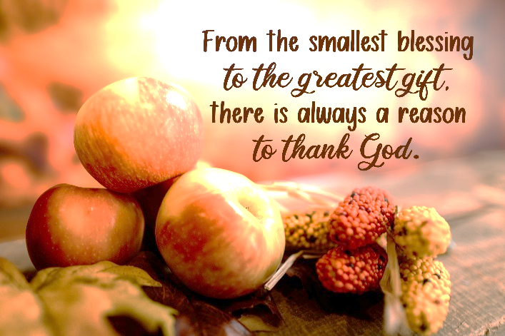

We have openings on our 2026 Flower Chart for November 29 and December 6 & 20. Flowers on the altar is a nice way to honor an anniversary, birthday, or remember a loved one who is no longer with us. Flowers are only $15, and you can drop a check in the offering plate, marking in the memo line, “altar flowers.” The 2027 Flower Chart is now up, alongside our current flower chart. Take a minute to reserve your date for altar flowers for next year.

To My Church Family ~ The Healing Private Wounds Board wants to thank you for allowing us to hold our Volunteer Appreciation party at our church. Our church is such a welcoming, loving place. It was the perfect place to celebrate what we do! Thanks so much! Shirley Petersen and HPW Board

The food distribution for November will go to Family Care Network in Manton. They can use cereal, canned beans, packaged noodles, tuna, and canned chicken. Please place your donations in the food storage container located between the double front doors. Thank you for your generosity.



Thank you to everyone for the beautiful prayer quilt and the accompanying prayers. Please continue to pray for a successful surgery and recovery for me. Also, thank you for the teddy bear, which will get a lot of hugging during my recovery! I appreciate the overwhelming kindness shown to me while I have been joining you in worship the last 6-7 years. Your kindness has meant so much to me. I have made some amazing friendships here. And thank you to those who have taken the time to drive me to Traverse City for testing appointments. I love you all so much! Skip Pluger
Today’s Worship Ministry…………….
Organist/Pianist: Megan Leinke
Liturgist: Yvonne Bandelow
Greeters/Ushers: Jack Davis, Diana VanAntwerp, Sheryl Blanchard
Cookies for Coffee Hour: Judy Davis, Open


Flowers on the Altar are given by
Gary & Yvonne Bandelow in
Appreciation of Our Church Volunteers.

The November Ministry Sign-Up Sheet for bringing cookies for Coffee Hour is on the food table in Fellowship Hall. We need two volunteers for November 15 & 22, and one for November 29. If you have never volunteered for this, please consider doing so.
A BIG Thank You to everyone who turned out for our Annual Outdoor Fall Cleanup! You did an amazing job beautifying our grounds. It is so appreciated!
Our November Loose Plate Offering will go to Council on Aging in Cadillac. God bless you for your constant generosity with your financial support. Reminder: If you wish to write a check, please make the check out to UMC Cadillac, with a note on the check’s memo line that it is for November Loose Plate.

Your tithes and offerings may be sent directly to the church at P.O. Box 37, Cadillac, MI 49601. If you wish to give online, you may scan the QR code to be connected to "Servant Keeper Online Giving." We thank you for your generosity.

