UNITED METHODIST CHURCH OF CADILLAC
REV. EARL DETWILER
SUNDAY, SEPTEMBER 6, 2026

PRELUDE

BRINGING IN THE LIGHT OF CHRIST

GREETING AND ANNOUNCEMENTS

WITH FAITH, ENTER INTO GOD’S DIVINE PRESENCE

*CALL TO WORSHIP UMH 159
“Lift High the Cross”

*HYMN OF PRAISE UMH 128
“He Leadeth Me: O Blessed Thought”

*UNISON OPENING PRAYER
I know you know, but I am a bit hard of hearing. I may wear hearing aids or not. I do not always hear what is said and often I do not interpret the words as they are meant. I confess that my own agenda gets in the way and impedes my ability to listen and hear what is said. I don’t enter into conversation with this in mind, it just happens. O God, inspire me by your Holy Spirit that I may clearly hear and understand that in all things you are active in the conversation. Help me to depend on you to hear and understand. At the end of the conversation help me to turn to you again and not to my own understanding that relationships may be saved and healed. In Jesus’ name. AMEN.

BY FAITH, WE LOOK INSIDE OUR LIVES

CALL TO REFLECTION UMH 885
“The Modern Affirmation”

A MOMENT FOR SILENCE

BY FAITH, WE SHARE IN THE WORD OF GOD

Dorothy Kunkel on violin
SPECIAL MUSIC Skip Pluger on piano
“O How He Loves You & Me!” Arr. Paul Mickelson
“Thou Art Worthy” Arr. Rick Powell
SCRIPTURE READING Matthew 18:15-20

SERMON Pastor Earl Detwiler
“Two Ears, One Mouth”

BY FAITH, WE RESPOND TO GOD’S CALL

HYMN OF RESPONSE TFWS 2226
“Bind Us Together”

SERVICE OF HOLY COMMUNION
(You may bring your offering forward with you and place it in the offering plate.)

MINISTRY OF PRAYER
Sharing our Joys and Concerns
Pastoral Prayer
The Lord’s Prayer
Our Father, who art in heaven, hallowed be thy name. Thy kingdom come, thy will be done on earth as it is in heaven. Give us this day our daily bread. And forgive us our trespasses, as we forgive those who trespass against us. And lead us not into temptation but deliver us from evil. For thine is the kingdom, and the power, and the glory forever. Amen.

BLESSING OUR GIFTS TO GOD
*Doxology UMH 95
“Praise God, From Whom All Blessings Flow”

*Prayer Of Dedication

WE GO FORTH TO SERVE

*CLOSING HYMN TFWS 2223
“They’ll Know We Are Christians by Our Love”

*BENEDICTION

*POSTLUDE

****************************************
Special Thanks to Dorothy Kunkel
and Skip Pluger for providing
our Special Music this morning.

United Methodist Church
of Cadillac
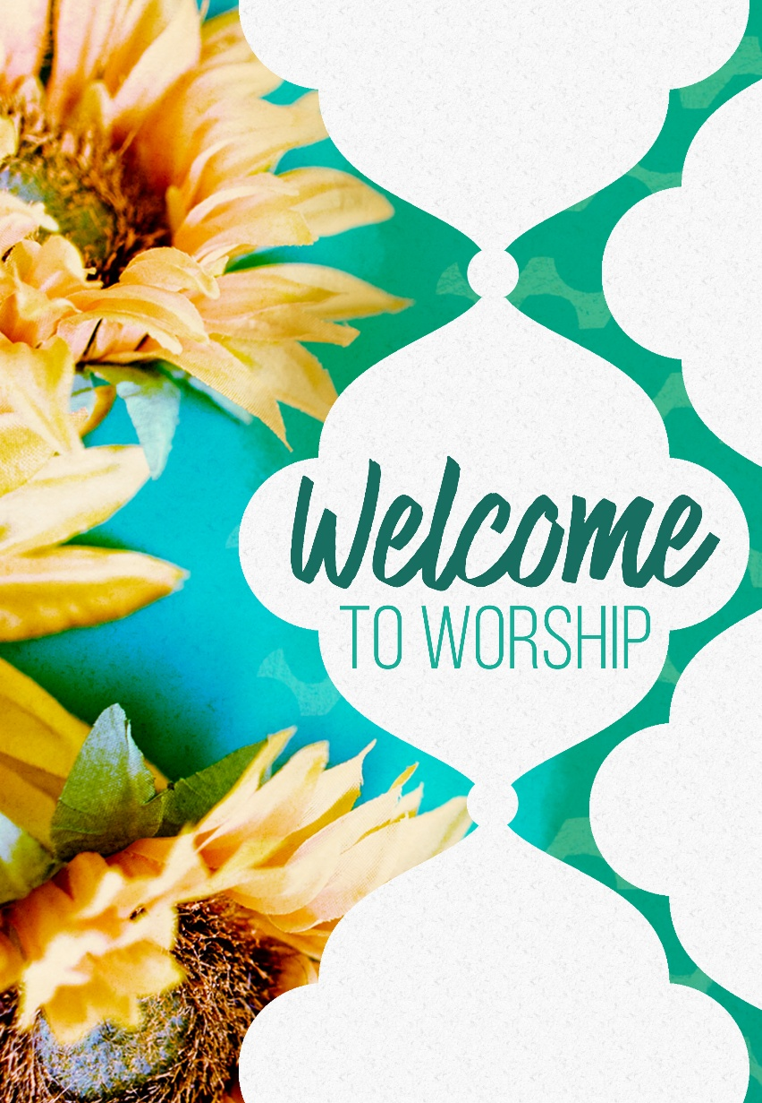
Sunday, September 6, 2026

