UNITED METHODIST CHURCH OF CADILLAC
REV. EARL DETWILER
SUNDAY, SEPTEMBER 13, 2026

PRELUDE

BRINGING IN THE LIGHT OF CHRIST

GREETING AND ANNOUNCEMENTS

THE PUPPETS RETURN!

WITH FAITH, ENTER INTO GOD’S DIVINE PRESENCE

*CALL TO WORSHIP UMH 657
“This Is the Day”

*HYMN OF PRAISE UMH 64
“Holy, Holy, Holy! Lord God Almighty”

*UNISON OPENING PRAYER
God, let’s get down to the core. People are hard to understand. About the time I think all is well, nope, something else crops up. And then, of all things, you ask me to let go and forgive? You must have an insight that I cannot grasp. To think that Jesus, your only son, died for them too? Lord, touch me with your Holy Spirit and lead me into all truth as your scripture says. I am trying to be a good Christian, but I really need your help. Touch me, in Jesus’s name. AMEN

BY FAITH, WE LOOK INSIDE OUR LIVES

CALL TO REFLECTION UMH 881
“The Apostles’ Creed” traditional version

A MOMENT FOR SILENCE

BY FAITH, WE SHARE IN THE WORD OF GOD

SPECIAL MUSIC Ruth Boonzaaijer Selby on Clarinet
Composer Chris Selby Chris Selby on Flute
“The Ring of Kerry”
“O’Grady of Kilkenny”

SCRIPTURE READING Matthew 18:21-35

SERMON Pastor Earl Detwiler
“Forgive? Why?”

BY FAITH, WE RESPOND TO GOD’S CALL

HYMN OF RESPONSE UMH 378
“Amazing Grace”

MINISTRY OF PRAYER
Sharing our Joys and Concerns
Pastoral Prayer
The Lord’s Prayer
Our Father, who art in heaven, hallowed be thy name. Thy kingdom come, thy will be done on earth as it is in heaven. Give us this day our daily bread. And forgive us our trespasses, as we forgive those who trespass against us. And lead us not into temptation but deliver us from evil. For thine is the kingdom, and the power, and the glory forever. Amen.

BLESSING OUR GIFTS TO GOD
Offertory

*Doxology UMH 95
“Praise God, From Whom All Blessings Flow”

* Prayer of Dedication

WE GO FORTH TO SERVE

*CLOSING HYMN UMH 572
“Pass It On”

*BENEDICTION

*POSTLUDE

United Methodist Church
of Cadillac
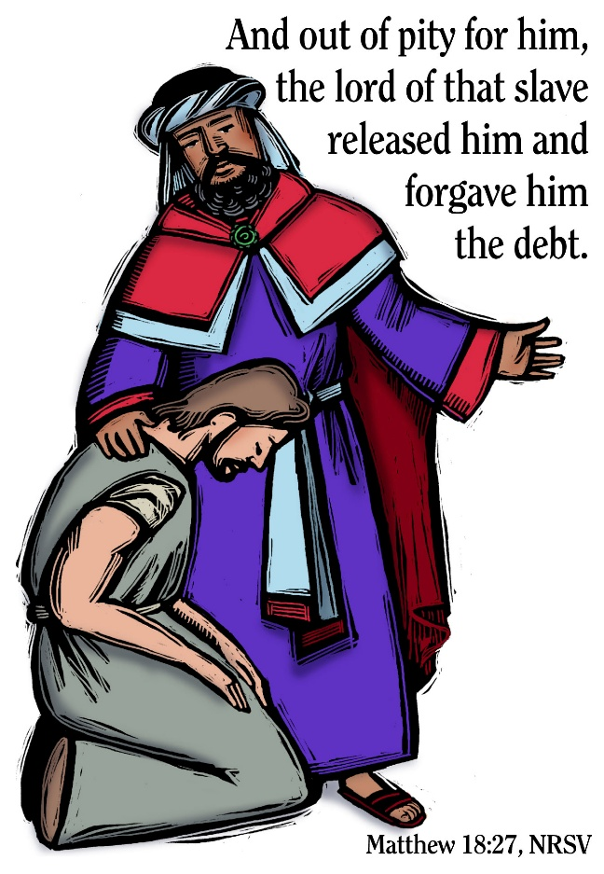

September 13, 2026

