UNITED METHODIST CHURCH OF CADILLAC
REV. EARL DETWILER
SUNDAY, AUGUST 9, 2026

PRELUDE

BRINGING IN THE LIGHT OF CHRIST

GREETING AND ANNOUNCEMENTS

WITH FAITH, ENTER INTO GOD’S DIVINE PRESENCE

*CALL TO WORSHIP UMH 145
“Morning Has Broken”

*HYMN OF PRAISE UMH 399
“Take My Life, and Let It Be”

*UNISON OPENING PRAYER
Your Word says, “All things are possible with God.” Every day we deal with possibilities. Alternatives comprise experiences and we are constantly forced to choose and follow though. We can receive benefit from our choices, but we also can receive consequences. Many times, outcomes are unknown until completion. You are a great God and your participation in our lives helps us make choices and cope with our outcomes. In all things you are working for our good. Thank you for your continued faithfulness. In Jesus’ name, AMEN.

BY FAITH, WE LOOK INSIDE OUR LIVES

CALL TO REFLECTION UMH 886
“The World Methodist Social Affirmation”

A MOMENT FOR SILENCE

BY FAITH, WE SHARE IN THE WORD OF GOD

SPECIAL MUSIC Ruth Boonzaaijer Selby on clarinet
Chris Selby on flute
“There is a Fountain” traditional, arranged by Nigel Williams

SCRIPTURE READING Matthew 14:22-33

SERMON Pastor Earl Detwiler
“Surface Tension”

BY FAITH, WE RESPOND TO GOD’S CALL

HYMN OF RESPONSE UMH 368
“My Hope Is Built”

MINISTRY OF PRAYER
Sharing our Joys and Concerns
Pastoral Prayer
The Lord’s Prayer
Our Father, who art in heaven, hallowed be thy name. Thy kingdom come, thy will be done on earth as it is in heaven. Give us this day our daily bread. And forgive us our trespasses, as we forgive those who trespass against us. And lead us not into temptation but deliver us from evil. For thine is the kingdom, and the power, and the glory forever. Amen.

BLESSING OUR GIFTS TO GOD
Offertory

*Doxology UMH 95
“Praise God, From Whom All Blessings Flow”

* Prayer of Dedication

WE GO FORTH TO SERVE

*CLOSING HYMN UMH 733
“Marching to Zion”

*BENEDICTION

*POSTLUDE

UNITED METHODIST CHURCH
OF CADILLAC

August 9, 2026

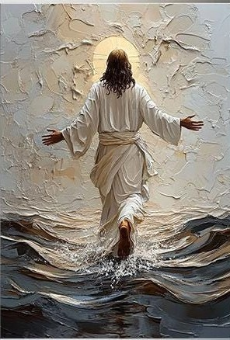

Matthew 14:22-33

