UNITED METHODIST CHURCH OF CADILLAC
REV. EARL DETWILER
SUNDAY, AUGUST 23, 2026

PRELUDE

BRINGING IN THE LIGHT OF CHRIST

GREETING AND ANNOUNCEMENTS

WITH FAITH, ENTER INTO GOD’S DIVINE PRESENCE

*CALL TO WORSHIP TFWS 2152
“Change My Heart, O God”

*HYMN OF PRAISE UMH 402
“Lord, I Want to Be a Christian”

*UNISON OPENING PRAYER
You gave us your Word, O God. The knowledge it brings helps us to understand our history and our lives every day. Your Word gives us insight into the dynamics of our daily experiences. Your Word gives us a growing ability to believe. From our belief comes faith and faith helps us to cope and manage the future. You give us all we need to deal with life. Help us, O Lord, to receive it and use it. In Jesus’ name, AMEN.

BY FAITH, WE LOOK INSIDE OUR LIVES

CALL TO REFLECTION UMH 881
“The Apostles’ Creed, Traditional Version”

A MOMENT FOR SILENCE

BY FAITH, WE SHARE IN THE WORD OF GOD

SPECIAL MUSIC vocalists, Aubrey & Addie Bailey
“He Reigns” by Steve Taylor & Peter Furler

SCRIPTURE READING Matthew 16:13-20

SERMON Pastor Earl Detwiler
“Faith-Wise”

BY FAITH, WE RESPOND TO GOD’S CALL

HYMN OF RESPONSE TFWS 2158
“Just a Closer Walk with Thee”

MINISTRY OF PRAYER
Sharing our Joys and Concerns
Pastoral Prayer
The Lord’s Prayer
Our Father, who art in heaven, hallowed be thy name. Thy kingdom come, thy will be done on earth as it is in heaven. Give us this day our daily bread. And forgive us our trespasses, as we forgive those who trespass against us. And lead us not into temptation but deliver us from evil. For thine is the kingdom, and the power, and the glory forever. Amen.

BLESSING OUR GIFTS TO GOD
Offertory

*Doxology UMH 95
“Praise God, From Whom All Blessings Flow”

* Prayer of Dedication

WE GO FORTH TO SERVE

*CLOSING HYMN On Overhead
“One Day at a Time”

*BENEDICTION

*POSTLUDE

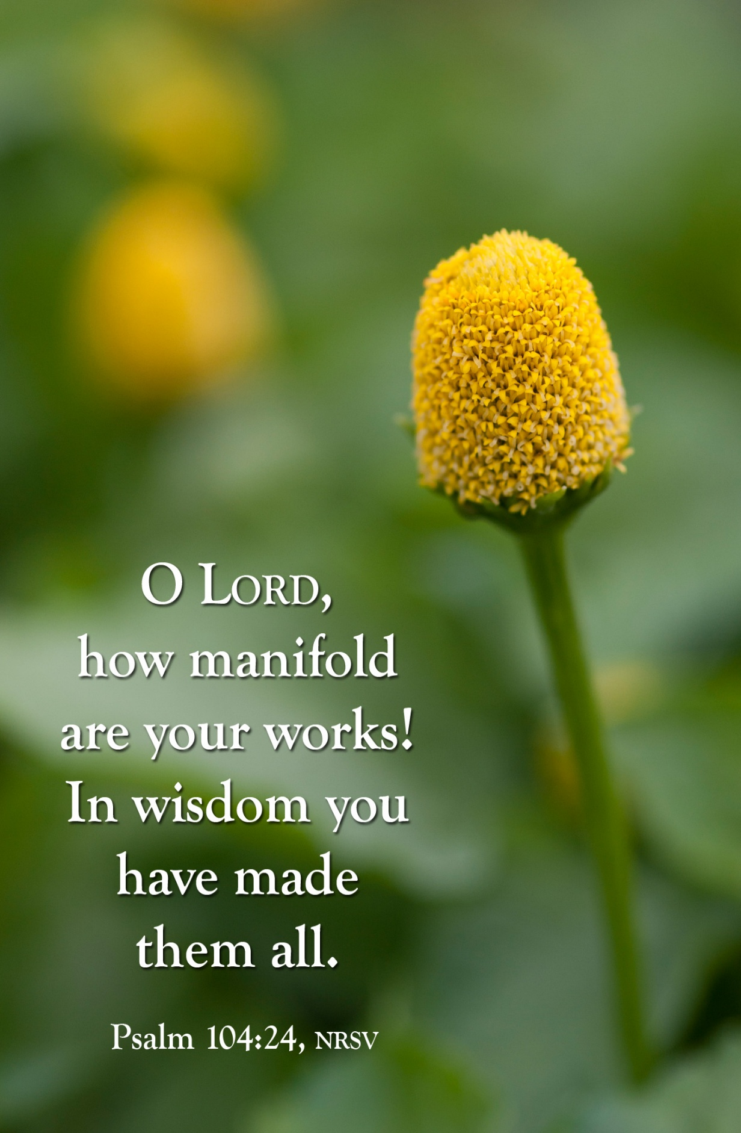
August 23, 2026
United Methodist Church
of Cadillac
August 23, 2026
United Methodist Church
Of Cadillac

