
Upcoming Birthdays
August 9 – Diane Wilkinson
August 12 – Dan Kinney
August 13 – Helen Quinn
August 15 – Donna McCormick

Pastor Earl Detwiler
Email: broffermoon@gmail.com
Phone: 785.213.1886
Prayer Requests (email): umccadillac@gmail.com
Church Website: www.cadillacumc.org
Church Email: umccadillac@gmail.com
Church Mailing Address: PO Box 37, Cadillac, MI 49601
Phone: (231) 775.5362
Office Hours: Monday - Thursday 10:00 a.m. - 4:00 p.m.
Pastor Earl’s Office Hours: Monday – Thursday 9:30 am – 1:00 pm
Closed on Fridays

Volunteer Ministry for Sunday, August 16, 2026
Organist/Pianist: Skip Pluger
Liturgist: Deb DeBruyn
Ushers/Greeters: Jack Davis, Jerry Deer, Dan & Sue Nelson
3 dozen cookies (each) for Coffee Hour: Diana Detwiler, Open
____________________________________________________________
CHURCH STAFF
Pastor: Rev. Earl Detwiler
Office Manager: Diane Coon
Treasurer: Sara Austin
Choir Director: Megan Leineke
Organists/Pianists: Ruth Boonzaaijer, Megan Leineke, Skip Pluger,
Dr. Glenn Verbrugge
Nursery: Diana VanAntwerp

What’s Happening at Church This Week………
Sunday, August 9
Blood Pressure Clinic before & after Service
10:30 a.m. – Worship Service

Monday, August 10
3:00 p.m. – Prayer Group in Wesley Room
6:30 p.m. – Freedom Festival Board Mtg in Corbin Room
7:00 p.m. – Scout Troop #125 in Fellowship Hall
Tuesday, August 11
12:00 Noon – Ladies Lunch in Fellowship Hall
12:00 Noon – Mens Lunch in Corbin Room
5:00 p.m. – Church Leadership Board Mtg in Corbin Room
Wednesday, August 12
10:30 a.m. – 12:30 p.m. – Weight Loss Group in Corbin Room
5:30 – 7:00 p.m. – Final Refuge Church VBS using FH & Youth Room
7:00 p.m. – Alcoholics Anonymous in Corbin Room
Thursday, August 13
3:00 – 5:00 p.m. – Patriot Choir in Corbin Room
Friday, August 14 – Church Office Closed
8:00 p.m. – Alcoholics Anonymous in Corbin Room

Sunday, August 16
10:30 a.m. – Worship Service
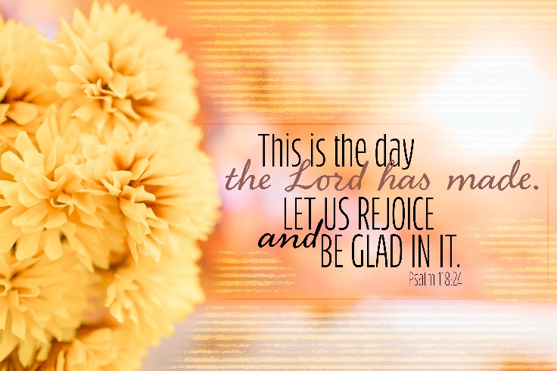

We have openings on our 2026 Flower Chart for November 1 & 29 and December 6 & 20. Flowers on the altar is a nice way to honor an anniversary, birthday, or remember a loved one who is no longer with us. Flowers are only $15, and you can drop a check in the offering plate, marking in the memo line, “altar flowers.”

Our brother-in-law, Ed Harris, has set up a camp scholarship fund at the Lake Louise Christian Retreat Center in Boyne Falls, MI in memory of our sister, Elaine. This is open to any friends and family of Elaine. If you are interested or would like to apply for the Elaine Peterson Harris scholarship, please contact Neil Haney, the Executive Director at
execdirector@lakelouisecommunity.org
Diana (Peterson) VanAntwerp
Carolyn (Peterson) Shook

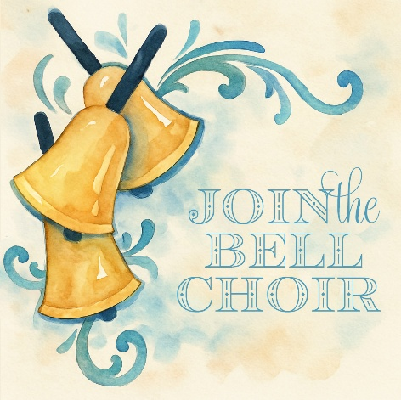
Bell Choir is coming! Are you interested in being part of this music ministry at UMC Cadillac? We can use lots of hands and enthusiasm. No prior experience or ability to read music is required. We will all be learning together and having a lot of fun and fellowship along the way. If interested in joining us, please email Diane Wilkinson at Blade0854@gmail.com with your name, phone number and email address. You can also text to (520) 204-7397 with the same information. We will begin practice in September. If you have any questions, please feel free to call, text, or email Diane.
Today’s Worship Ministry…………….
Organist/Pianist: Ruth Boonzaaijer
Liturgist: Judy Houts
Greeters/Ushers: Jack Davis, Dan & Sue Nelson
3 dozen cookies (each) for Coffee Hour: Jean Lakin, Bev Campbell



Flowers on the Altar are given by
Dan & Laurie Kinney in Honor of
Dan’s Birthday on August 12.

The August Volunteer Ministry Sign-Up Sheet for bringing cookies for Coffee Hour is on the food table in Fellowship Hall. We still need 1 for August 16 & 23 and 2 for August 30. If you have never volunteered for this, please consider doing so.

Our Food Distribution for August will go to Mesick’s Food Pantry. They can use peanut butter, cereal, spaghetti, canned spaghetti sauce, instant potatoes, or any other non-perishable food items. Please place your donations in the food storage containers located between the double front doors. Thank you for your generosity.


Your tithes and offerings may be sent directly to the church at P.O. Box 37, Cadillac, MI 49601. If you wish to give online, you may scan the QR code to be connected to "Servant Keeper Online Giving." We thank you for your generosity.

