
Upcoming Birthdays
August 30 – Jim Petersen
August 31 – Dick Jones
September 1 – Judy Coffey
September 3 – Joan Deer
September 6 – Jerry Deer,
Craig Greenman

Pastor Earl Detwiler
Email: broffermoon@gmail.com
Phone: 785.213.1886
Prayer Requests (email): umccadillac@gmail.com
Church Website: www.cadillacumc.org
Church Email: umccadillac@gmail.com
Church Mailing Address: PO Box 37, Cadillac, MI 49601
Phone: (231) 775.5362
Office Hours: Monday - Thursday 10:00 a.m. - 4:00 p.m.
Pastor Earl’s Office Hours: Monday – Thursday 9:30 am – 1:00 pm
Closed on Fridays

Volunteer Ministry for Sunday, September 6, 2026
Organist/Pianist: Skip Pluger
Liturgist: Laurie Kinney
Ushers/Greeters: Jack Davis, Diana VanAntwerp, Sheryl Blanchard
3 dozen cookies (each) for Coffee Hour: None needed/Picnic
____________________________________________________________
CHURCH STAFF
Pastor: Rev. Earl Detwiler
Office Manager: Diane Coon
Treasurer: Sara Austin
Choir Director: Megan Leineke
Organists/Pianists: Ruth Boonzaaijer, Megan Leineke, Skip Pluger,
Dr. Glenn Verbrugge
Nursery: Diana VanAntwerp
What’s Happening at Church This Week………
Sunday, August 30
10:30 a.m. – Worship Service

Monday, August 31
3:00 p.m. – Prayer Group in Wesley Room
7:00 p.m. – Scout Troop #125 in Fellowship Hall
Tuesday, September 1
Office Manager, Diane Coon, Out of Office
Wednesday, September 2 -Diane Coon Out of Office
10:30 a.m. – 12:30 p.m. – Weight Loss Group in Corbin Room
4:00 p.m. – Choir Practice Resumes
7:00 p.m. – Alcoholics Anonymous in Corbin Room
Thursday, September 3
3:00 – 5:00 p.m. – Patriot Choir in Corbin Room
Friday, September 4– Church Office Closed
8:00 p.m. – Alcoholics Anonymous in Corbin Room

Sunday, September 6
10:30 a.m. – Worship Service w/Holy Communion
11:40 a.m. – 2:00 p.m. – All Church Picnic

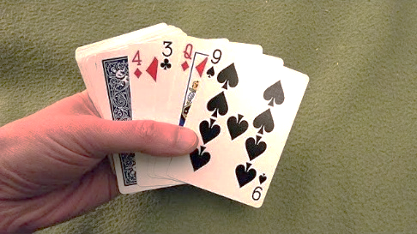

Game Night Returns!
Join us on Wednesday, September 9 at 5:00 p.m. in Fellowship Hall for an evening of cards, fun and fellowship!
Volunteers Needed for Childrens Storytime/Craft & Nursery


We are looking for volunteers that would be willing to serve once a month either reading/crafting with children (kindergarten – 5th grade) or caring for infants/toddlers in our nursery during our church service. The story and craft is already pre-planned, very easy and requires no preparation work on your part. These volunteer opportunities would all depend on whether we have children in the service on any particular Sunday. If there are no children or babies the Sunday you volunteered for, you can join in the church service. A signup sheet can be found on our Information Center. Questions? Please speak with Pastor Earl.

Our Loose Plate for September will go to Vets serving Vets. This donation will allow Vets serving Vets to purchase perishable food items (meat, fresh fruits & vegetables) for their veterans. Reminder: If you wish to write a check, please make the check out to UMC Cadillac, with a note on the memo line that it is for September Loose Plate.

Our Food Distribution for September will go to Love INC’s Food Pantry. They can use peanut butter, cereal, mac & cheese, spaghetti, canned spaghetti sauce, crackers, tuna or any other non-perishable food items. Please place your donations in the food storage containers located between the double front doors. Thank you for your generosity.

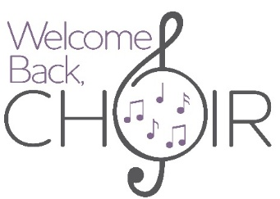
Choir resumes for the season! First choir practice will be on Wednesday, September 2 at 4:00 p.m.
Today’s Worship Ministry…………….
Organist/Pianist: Dr. Glenn Verbrugge
Liturgist: Jeff Hinkston
Greeters/Ushers: Open
3 dozen cookies (each) for Coffee Hour: Lark Miller, Kay Hinkston


Flowers on the Altar are given by
Diana VanAntwerp In Loving Memory of
Sister, Elaine Harris

The September Ministry Sign-Up Sheet for bringing cookies for Coffee Hour is on the food table in Fellowship Hall. We are still in need of 1 volunteer for September 13, 2 for September 20 and 2 for September 27. If you have never volunteered for this, please consider doing so.

Do you have a shelving unit that you are no longer using? The church could use some shelving units to store our extra non-perishable food items that we will be collecting during our Fred Carroll Memorial Food Drive next month. If you can donate a shelving unit, please contact Diane in the office or Pastor Earl.


Your tithes and offerings may be sent directly to the church at P.O. Box 37, Cadillac, MI 49601. If you wish to give online, you may scan the QR code to be connected to "Servant Keeper Online Giving." We thank you for your generosity.

