UNITED METHODIST CHURCH OF CADILLAC
REV. EARL DETWILER
SUNDAY, JULY 19, 2026

PRELUDE

BRINGING IN THE LIGHT OF CHRIST

GREETING AND ANNOUNCEMENTS

WITH FAITH, ENTER INTO GOD’S DIVINE PRESENCE

*CALL TO WORSHIP UMH 133
“Leaning on the Everlasting Arms”

*HYMN OF PRAISE UMH 77
“How Great Thou Art”

*UNISON OPENING PRAYER
Dear God, there are so many memories in my head. Some of them good, others of them, well, not so good. As I live my life, experiences and events trigger the thought of those events. Quite honestly, sometimes the pain of memory takes my joy. Other times, I become overwhelmed by gratitude and thanksgiving for what occurred. My tears express the joy of what happened. You have blessed me, O God. Your attention to my life has brought much to it. Be with me always, in Jesus’ name. AMEN.

BY FAITH, WE LOOK INSIDE OUR LIVES

CALL TO REFLECTION UMH 884
“The Korean Methodist Statement of Faith”

A MOMENT FOR SILENCE

BY FAITH, WE SHARE IN THE WORD OF GOD

SPECIAL MUSIC Dorothy Kunkel on violin
Skip Pluger on piano
“Spirit of God, Descend upon My Heart”
FT Atkinson * Arr. Don Whitman

SCRIPTURE READING Matthew 13:24-30, 36-43

SERMON Pastor Earl Detwiler
“Harvest Time”

BY FAITH, WE RESPOND TO GOD’S CALL

HYMN OF RESPONSE UMH 347
“Spirit Song”

MINISTRY OF PRAYER
Sharing our Joys and Concerns
Pastoral Prayer
The Lord’s Prayer
Our Father, who art in heaven, hallowed be thy name. Thy kingdom come, thy will be done on earth as it is in heaven. Give us this day our daily bread. And forgive us our trespasses, as we forgive those who trespass against us. And lead us not into temptation but deliver us from evil. For thine is the kingdom, and the power, and the glory forever. Amen.

BLESSING OUR GIFTS TO GOD
Offertory

*Doxology UMH 95
“Praise God, From Whom All Blessings Flow”

*Prayer of Dedication

WE GO FORTH TO SERVE

*CLOSING HYMN UMH 382
“Have Thine Own Way, Lord”

*BENEDICTION

*POSTLUDE

UNITED METHODIST CHURCH
OF CADILLAC

July 19, 2026

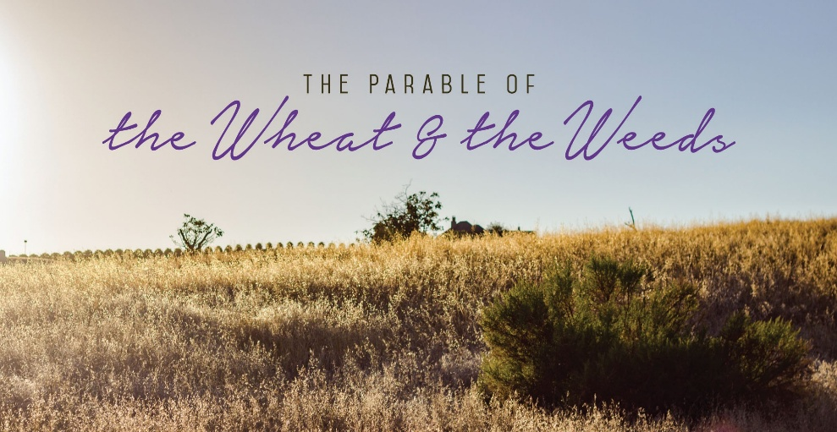

Our Mission Statement
With God’s help, we will
welcome,
love,
value,
grow,
guide,
and serve everyone.

