UNITED METHODIST CHURCH OF CADILLAC
REV. EARL DETWILER
SUNDAY, JULY 12, 2026

PRELUDE

BRINGING IN THE LIGHT OF CHRIST

GREETING AND ANNOUNCEMENTS

THE PUPPETS

WITH FAITH, ENTER INTO GOD’S DIVINE PRESENCE

*CALL TO WORSHIP UMH 349
“Turn Your Eyes upon Jesus”

*HYMN OF PRAISE UMH 98
“To God be the Glory”

*UNISON OPENING PRAYER
God, life must have purpose. See, I think there is a reason for everything. For life to make sense, I need an answer. I need to know why. I need to know meaning. I need to know the outcome. Yet, you tell me to live by faith. You say, “Trust Me!” Please understand how difficult it is for me to do just that. I know what a great God you are, and I know that you love me, please help me today to take the next step and believe you no matter what. In Jesus’ name, AMEN.

BY FAITH, WE LOOK INSIDE OUR LIVES

CALL TO REFLECTION UMH 883
“The Canadian United Methodist Statement of Faith”

A MOMENT FOR SILENCE

BY FAITH, WE SHARE IN THE WORD OF GOD

SPECIAL MUSIC Ruth Boonzaaijer Selby on clarinet
Chris Selby on saxophone
“Blst Du Bei Mire”
Johann Sebastian Bach

SCRIPTURE READING Matthew 13:1-9, 18-23

SERMON Pastor Earl Detwiler
“Sour Sower”

BY FAITH, WE RESPOND TO GOD’S CALL

HYMN OF RESPONSE UMH 351
“Pass Me Not, O Gentle Savior”

MINISTRY OF PRAYER
Sharing our Joys and Concerns
Pastoral Prayer
The Lord’s Prayer
Our Father, who art in heaven, hallowed be thy name. Thy kingdom come, thy will be done on earth as it is in heaven. Give us this day our daily bread. And forgive us our trespasses, as we forgive those who trespass against us. And lead us not into temptation but deliver us from evil. For thine is the kingdom, and the power, and the glory forever. Amen.

BLESSING OUR GIFTS TO GOD
Offertory

*Doxology UMH 95
“Praise God, From Whom All Blessings Flow”

* Prayer of Dedication

WE GO FORTH TO SERVE

*CLOSING HYMN UMH 367
“He Touched Me”

*BENEDICTION

*POSTLUDE

UNITED METHODIST CHURCH
OF CADILLAC

July 12, 2026

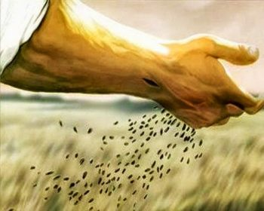

“Sour Sower”

Our Mission
To Lead Everyone in Relationship with Christ.

Our Vision
Bringing people to Christ; developing personal
growth in Christ; putting Christ into action.

