
Upcoming Birthdays
July 31 – Linda Everett
August 2 – Tim Coffey
August 3 – Bonnie Salmon
August 4 – Lark Miller
August 8 – Jessica Danford
August 9 – Diane Wilkinson

Pastor Earl Detwiler
Email: broffermoon@gmail.com
Phone: 785.213.1886
Prayer Requests (email): umccadillac@gmail.com
Church Website: www.cadillacumc.org
Church Email: umccadillac@gmail.com
Church Mailing Address: PO Box 37, Cadillac, MI 49601
Phone: (231) 775.5362
Office Hours: Monday - Thursday 10:00 a.m. - 4:00 p.m.
Pastor Earl’s Office Hours: Monday – Thursday 9:30 am – 1:00 pm
Closed on Fridays

Volunteer Ministry for Sunday, August 2, 2026
Organist/Pianist: Skip Pluger
Liturgist: Laurie Kinney
Ushers/Greeters: Jack Davis, Sheryl Blanchard, Diana VanAntwerp
3 dozen cookies (each) for Coffee Hour: Open
____________________________________________________________
CHURCH STAFF
Pastor: Rev. Earl Detwiler
Office Manager: Diane Coon
Treasurer: Sara Austin
Choir Director: Megan Leineke
Organists/Pianists: Ruth Boonzaaijer, Megan Leineke, Skip Pluger,
Dr. Glenn Verbrugge
Nursery: Diana VanAntwerp
What’s Happening at Church This Week………
Sunday, July 26
10:30 a.m. – Worship Service
1:00 – 4:00 p.m. – Peterson Family Reunion in Fellowship Hall

Monday, July 27
9:00 a.m. – 2:00 p.m. – Jam & Bread Summer Exploration Outdoors
3:00 p.m. – Prayer Group in Wesley Room
7:00 p.m. – Scout Troop #125 in Fellowship Hall
Wednesday, July 29
10:30 a.m. – 12:30 p.m. – Weight Loss Group in Corbin Room
5:30 – 7:00 p.m. – Refuge Church VBS using FH & Youth Room
7:00 p.m. – Alcoholics Anonymous in Corbin Room
Thursday, July 30
3:00 – 5:00 p.m. – Patriot Choir in Corbin Room
Friday, July 31 – Church Office Closed
8:00 p.m. – Alcoholics Anonymous in Fellowship Hall

Sunday, August 2
10:30 a.m. – Worship Service w/Holy Communion
12:30 - 3:00 p.m. – Lunch & Car Show Here to Benefit
Freedom Festival 2027

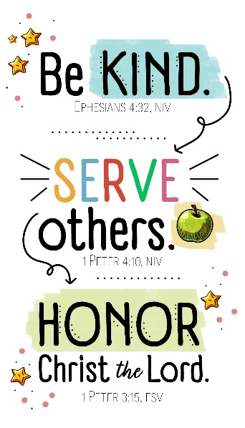

We have openings on our 2026 Flower Chart for November 1, 22 & 29 and December 6 & 20. Flowers on the altar is a nice way to honor an anniversary, birthday, or remember a loved one who is no longer with us. Flowers are only $15, and you can drop a check in the offering plate, marking in the memo line, “altar flowers.”

Volunteers from our church will be passing out water bottles at the Clam Lake Band’s Monday evening performance at the Pavillion on August 3 at 7:00 p.m. Come on out and enjoy a great time of music, and, if able, pass out some water bottles!

Our Loose Plate for August will go to Pastor’s Discretionary Fund. This fund allows for Pastor to help individuals in the community in their time of need. Sometimes that translates to filling a gas tank, or motel lodging for a night or two. God bless you for your constant generosity with your financial support. Reminder: If you wish to write a check, please make the check out to UMC Cadillac, with a note on the memo line that it is for August Loose Plate.

Our Food Distribution for August will go to Mesick’s Food Pantry. They can use peanut butter, cereal, spaghetti, canned spaghetti sauce, instant potatoes, or any other non-perishable food items. Please place your donations in the food storage containers located between the double front doors. Thank you for your generosity.


The Pit Spitters Ballgame that was to take place on July 16 has been rescheduled for Thursday, July 30 at 7:05 p.m.

Today’s Worship Ministry…………….
Organist/Pianist: Megan Leineke
Liturgist: Bob Garner
Greeters/Ushers: Jack Davis, Margaret Himes, Kay Hinkston,
Bob Newland
3 dozen cookies (each) for Coffee Hour: Patti Bovee, Nancy Carmean

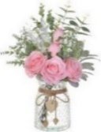
Flowers on the Altar are given by
Gary & Yvonne Bandelow in Honor of
Their 64th Wedding Anniversary on July 28th
and by Bob Everett in Honor of
Linda Everett’s Birthday on July 31
and by the Bassett & Greenman Families
in Remembrance of Dale Greenman’s Birthday on July 27.

The August Volunteer Ministry Sign-Up Sheet for bringing cookies for Coffee Hour is on the food table in Fellowship Hall. If you have never volunteered for this, please consider doing so.

Your tithes and offerings may be sent directly to the church at P.O. Box 37, Cadillac, MI 49601. If you wish to give online, you may scan the QR code to be connected to "Servant Keeper Online Giving." We thank you for your generosity.


