UNITED METHODIST CHURCH OF CADILLAC
REV. EARL DETWILER
SUNDAY, JUNE 14, 2026

PRELUDE

BRINGING IN THE LIGHT OF CHRIST

THE PUPPETS

GREETING AND ANNOUNCEMENTS (Amy and Sally)

WITH FAITH, ENTER INTO GOD’S DIVINE PRESENCE

*CALL TO WORSHIP UMH 349
“Turn Your Eyes upon Jesus”

*HYMN OF PRAISE UMH 64
“Holy, Holy, Holy! Lord God Almighty”

*UNISON OPENING PRAYER
Here we are, back together, God. I have believed in you as long as I can remember. You have been around when I needed help and looking back, you were there when I had my mind elsewhere. What is it about me that you find so interesting? The Bible says that you love everyone and actually paid the price for your constant attention. That was Jesus and the cross, wasn’t it? Today, I want to affirm my relationship with you. I will be your child if you will be my God. Okay? Through Jesus. AMEN

BY FAITH, WE LOOK INSIDE OUR LIVES

CALL TO REFLECTION

A MOMENT FOR SILENCE

BY FAITH, WE SHARE IN THE WORD OF GOD

SPECIAL MUSIC vocalist, Ruth Boonzaaijer
“My Worth Is Not In What I Own”
Keith & Kristyn Getty, Graham Kedrick

SCRIPTURE READING Micah 6:6-8

SERMON Joel Campbell

BY FAITH, WE RESPOND TO GOD’S CALL

HYMN OF RESPONSE UMH 451
“Be Thou My Vision”

MINISTRY OF PRAYER
Sharing our Joys and Concerns
Pastoral Prayer
The Lord’s Prayer
Our Father, who art in heaven, hallowed be thy name. Thy kingdom come, thy will be done on earth as it is in heaven. Give us this day our daily bread. And forgive us our trespasses, as we forgive those who trespass against us. And lead us not into temptation but deliver us from evil. For thine is the kingdom, and the power, and the glory forever. Amen.

BLESSING OUR GIFTS TO GOD
Offertory

*Doxology UMH 95
“Praise God, From Whom All Blessings Flow”

Prayer of Dedication

WE GO FORTH TO SERVE

*CLOSING HYMN UMH 395
“Take Time to Be Holy”

*BENEDICTION

*POSTLUDE

UNITED METHODIST CHURCH
OF CADILLAC

June 14, 2026
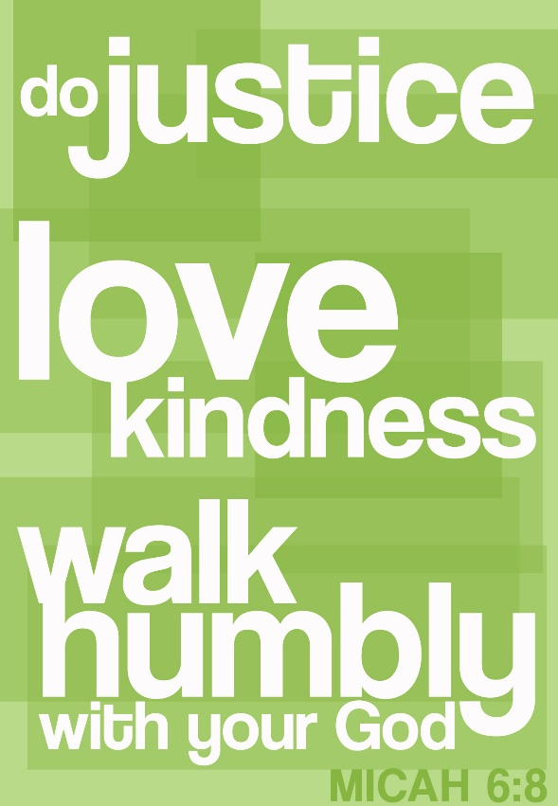

Our Mission
To Lead Everyone in Relationship with Christ.

Our Vision
Bringing people to Christ; developing personal
growth in Christ; putting Christ into action.

