UNITED METHODIST CHURCH OF CADILLAC
REV. EARL DETWILER
SUNDAY, MAY 10, 2026
MOTHERS DAY

PRELUDE Dr. Glenn Verbrugge

BRINGING IN THE LIGHT OF CHRIST

GREETING AND ANNOUNCEMENTS

THE PUPPETS ARE HERE!

WITH FAITH, ENTER INTO GOD’S DIVINE PRESENCE

*CALL TO WORSHIP UMH 177
“He Is Lord”

*OPENING HYMN UMH 474
“Precious Lord, Take My Hand”

*UNISON OPENING PRAYER
Lord, my parents are always with me. Even though they may be gone from this world or still nearby, their influence on my life is profound. We have talked about the bad times often before, and I may hang on to them too much. But Lord, I also remember the many good times. Those times that solidified my relationship and dominated my memories, I cherish so much. Today Lord, for better or worse, I lift up my parents to your glory, in Jesus’ name. AMEN

BY FAITH, WE LOOK INSIDE OUR LIVES

CALL TO REFLECTION

A MOMENT FOR SILENCE

BY FAITH, WE SHARE IN THE WORD OF GOD

SPECIAL MUSIC Mens Quartet
“The Gift of Love”

SCRIPTURE READING John 14:15-21

SERMON Pastor Earl Detwiler
“Blanket Coverage”

BY FAITH, WE RESPOND TO GOD’S CALL

HYMN OF RESPONSE UMH 338
“Where He Leads Me”

MINISTRY OF PRAYER
Sharing our Joys and Concerns
Pastoral Prayer
The Lord’s Prayer
Our Father, who art in heaven, hallowed be thy name. Thy kingdom come, thy will be done on earth as it is in heaven. Give us this day our daily bread. And forgive us our trespasses, as we forgive those who trespass against us. And lead us not into temptation but deliver us from evil. For thine is the kingdom, and the power, and the glory forever. Amen.

OFFERING OUR GIFTS TO GOD
Offertory Dr. Glenn Verbrugge
“Be Thou My Vision” by Paul Manz

*Doxology UMH 95
“Praise God, From Whom All Blessings Flow”

*PRAYER OF DEDICATION

WE GO FORTH TO SERVE

*CLOSING HYMN UMH 420
“Breathe on Me, Breath of God”

*BENEDICTION

*POSTLUDE Dr. Glenn Verbrugge
“All Hail the Power of Jesus” Name by David Cherwien

****************************************

Special thanks to the Mens Quartet
for providing the special music this morning:

Lyn Cryderman

Randy Myers

Art VanderHart

Dr. Glenn Verbrugge

UNITED METHODIST CHURCH
OF CADILLAC

May 10, 2026
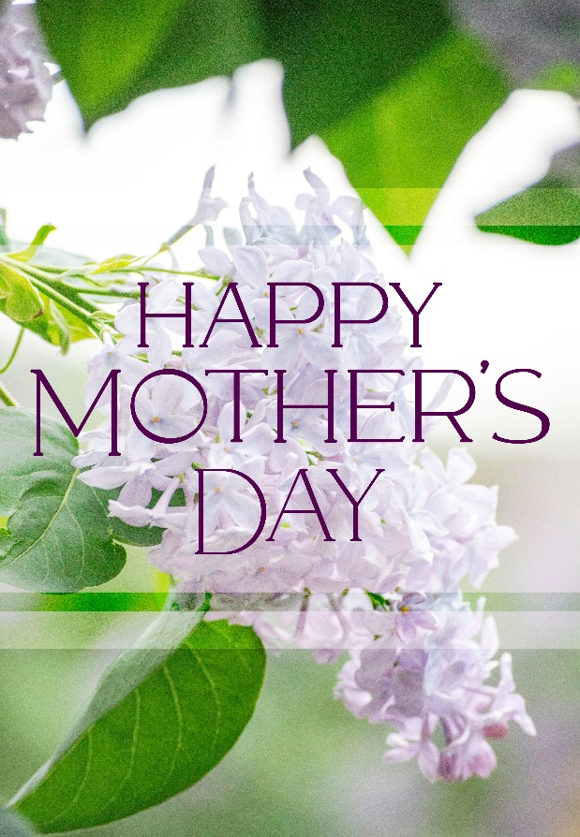

Our Mission
To Lead Everyone in Relationship with Christ.

Our Vision
Bringing people to Christ; developing personal
growth in Christ; putting Christ into action.

