UNITED METHODIST CHURCH OF CADILLAC
REV. EARL DETWILER
SUNDAY, MAY 3, 2026

PRELUDE

BRINGING IN THE LIGHT OF CHRIST

GREETING AND ANNOUNCEMENTS

WITH FAITH, ENTER INTO GOD’S DIVINE PRESENCE

*CALL TO WORSHIP UMH 507
“Through It All”

*HYMN OF PRAISE UMH 156
“I Love to Tell the Story”

*UNISON OPENING PRAYER
The other day, O God, I was thinking about you and what you mean to my life. I remembered the time you intervened on my attitude and turned a bad situation into a promise. I was thinking about the time you found me in a deep hole of despair, and you shone your light into the darkness. What a difference you made. I could go on and on but today I want you to know how much I appreciate you. Thank you God, in Jesus’ name. AMEN

BY FAITH, WE LOOK INSIDE OUR LIVES

CALL TO REFLECTION

A MOMENT FOR SILENCE

BY FAITH, WE SHARE IN THE WORD OF GOD

SCRIPTURE READING John 14:1-14

SERMON Pastor Earl Detwiler
“Life’s Uncertainty”

BY FAITH, WE RESPOND TO GOD’S CALL

MINISTRY OF PRAYER
Sharing our Joys and Concerns
Pastoral Prayer
The Lord’s Prayer
Our Father, who art in heaven, hallowed be thy name. Thy kingdom come, thy will be done on earth as it is in heaven. Give us this day our daily bread. And forgive us our trespasses, as we forgive those who trespass against us. And lead us not into temptation but deliver us from evil. For thine is the kingdom, and the power, and the glory forever. Amen.

SERVICE OF HOLY COMMUNION
(You may bring your offering forward with you and place it in the offering plate.)
Note: The Choir will be singing “In Remembrance” during communion, therefore please allow them to proceed to the communion rail first.

*Doxology UMH 95
“Praise God, From Whom All Blessings Flow”

*PRAYER OF DEDICATION

WE GO FORTH TO SERVE

*CLOSING HYMN UMH 133
“Leaning on the Everlasting Arms”

*BENEDICTION

*POSTLUDE

UNITED METHODIST CHURCH
OF CADILLAC

May 3, 2026
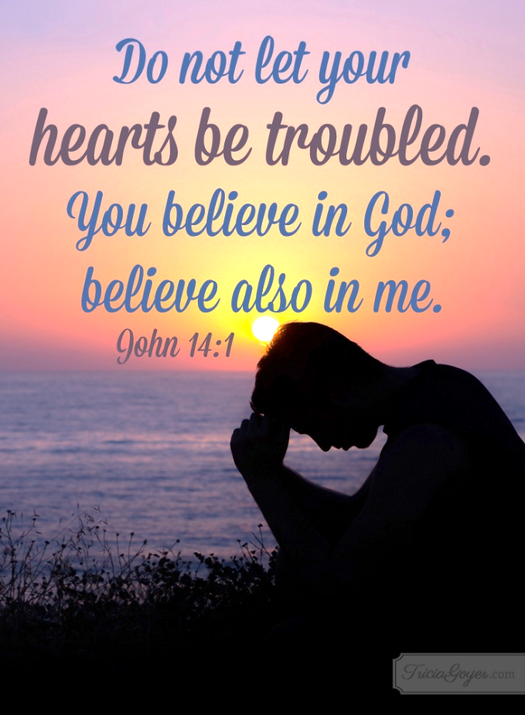

Our Mission
To Lead Everyone in Relationship with Christ.

Our Vision
Bringing people to Christ; developing personal
growth in Christ; putting Christ into action.

