UNITED METHODIST CHURCH OF CADILLAC
REV. EARL DETWILER
SUNDAY, APRIL 12, 2026

PRELUDE

BRINGING IN THE LIGHT OF CHRIST

WELCOME AND ANNOUNCEMENTS

WITH FAITH, ENTER INTO GOD’S DIVINE PRESENCE

*CALL TO WORSHIP UMH 328
“Surely the Presence of the Lord”

*OPENING HYMN UMH 314
“In the Garden”

*UNISON OPENING PRAYER
Oh, God, in your scripture today, Jesus gave the disciples the evidence they needed to know and spread the word of God. I wonder what kind of divine event it would take to inspire me to such faith. Is it possible that today your Holy Spirit could do such a huge task? Come, O Holy Spirit, in Jesus’ name. AMEN

BY FAITH, WE LOOK INSIDE OUR LIVES

CALL TO REFLECTION

A MOMENT FOR SILENT REFLECTION

BY FAITH, WE SHARE IN THE WORD OF GOD

SPECIAL MUSIC Ruth, Chris & Rachel
“Easter Alleluia Medley”
Robert Williams/Robert Lowry ⁕ Arr. Gary Lanler

SCRIPTURE READING John 20:19-31

SERMON Pastor Earl Detwiler
“Standard of Evidence”

BY FAITH, WE RESPOND TO GOD’S CALL

HYMN OF RESPONSE UMH 338
“Where He Leads Me”

MINISTRY OF PRAYER
Sharing our Joys and Concerns
Pastoral Prayer
The Lord’s Prayer
Our Father, who art in heaven, hallowed be thy name. Thy kingdom come, thy will be done on earth as it is in heaven. Give us this day our daily bread. And forgive us our trespasses, as we forgive those who trespass against us. And lead us not into temptation but deliver us from evil. For thine is the kingdom, and the power, and the glory forever. Amen.

SERVICE OF HOLY COMMUNION
(You may bring your offering forward with you and place it in the offering plate.)

*Doxology UMH 95
“Praise God, From Whom All Blessings Flow”

*PRAYER OF DEDICATION

WE GO FORTH TO SERVE

*CLOSING HYMN UMH 361
“Rock of Ages, Cleft for Me”

*BENEDICTION

*POSTLUDE

****************************************
Many thanks to
Ruth Boonzaaijer on Clarinet
Chris Selby on Flute
and Rachel Potter on piano
for providing our special music this morning.

UNITED METHODIST CHURCH
OF CADILLAC

April 12, 2026
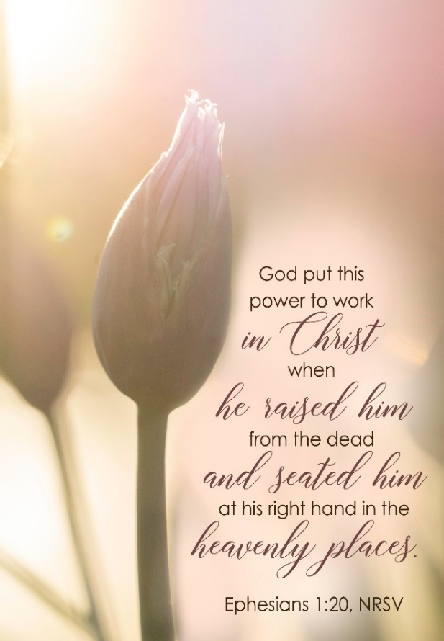

Our Mission
To Lead Everyone in Relationship with Christ.

Our Vision
Bringing people to Christ; developing personal
growth in Christ; putting Christ into action.

