UNITED METHODIST CHURCH OF CADILLAC
REV. EARL DETWILER
SUNDAY, APRIL 19, 2026

PRELUDE

BRINGING IN THE LIGHT OF CHRIST

WELCOME AND ANNOUNCEMENTS

WITH FAITH, ENTER INTO GOD’S DIVINE PRESENCE

*CALL TO WORSHIP TFWS 2038
“Father, I Adore You”

*OPENING HYMN UMH 261
“Lord of the Dance”

*UNISON OPENING PRAYER
Lord, the weather patterns have been difficult this year. Huge amounts of rain followed by another rain on another day, again. If we did not know better, God are you mad at us? Is there a problem that we feel like we need to address? Our God, we know you are a loving God, and you give us all we need to handle whatever this world throws at us, please reassure us in this service that your love is stronger than ever and your presence is exactly what is needed to overcome our challenges. In Jesus’ name. AMEN

BY FAITH, WE LOOK INSIDE OUR LIVES

CALL TO REFLECTION

A MOMENT FOR SILENCE

BY FAITH, WE SHARE IN THE WORD OF GOD

CHORAL ANTHEM Chancel Choir
“O, What a Man Was He!” Arr. Jay Althouse

SCRIPTURE READING Luke 24:13-35

SERMON Pastor Earl Detwiler
“Who is Who?”

BY FAITH, WE RESPOND TO GOD’S CALL

HYMN OF RESPONSE UMH 367
“He Touched Me”

MINISTRY OF PRAYER
Sharing our Joys and Concerns
Pastoral Prayer
The Lord’s Prayer
Our Father, who art in heaven, hallowed be thy name. Thy kingdom come, thy will be done on earth as it is in heaven. Give us this day our daily bread. And forgive us our trespasses, as we forgive those who trespass against us. And lead us not into temptation but deliver us from evil. For thine is the kingdom, and the power, and the glory forever. Amen.

OFFERING OUR GIFTS TO GOD
Offertory

*Doxology UMH 95
“Praise God, From Whom All Blessings Flow”

*PRAYER OF DEDICATION

WE GO FORTH TO SERVE

*CLOSING HYMN UMH 374
“Standing on the Promises”

*BENEDICTION

*POSTLUDE

UNITED METHODIST CHURCH
OF CADILLAC

April 19, 2026
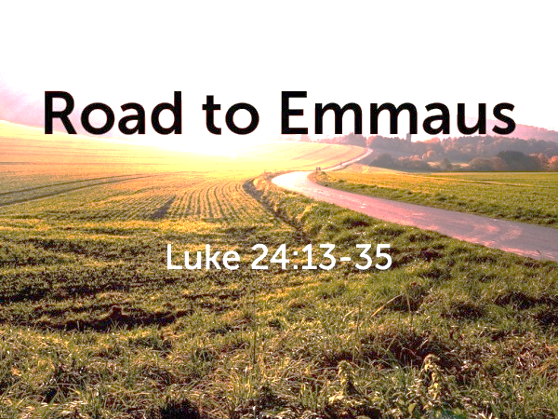

Our Mission
To Lead Everyone in Relationship with Christ.

Our Vision
Bringing people to Christ; developing personal
growth in Christ; putting Christ into action.

