
Upcoming Birthdays
February 16 – Mary Bell
February 17 – Yvonne Bandelow
February 24 – Ona Greenman
February 27 – Pastor Earl Detwiler

Pastor Earl Detwiler
Email: broffermoon@gmail.com
Phone: 785.213.1886
Prayer Requests (email): umccadillac@gmail.com
Church Website: www.cadillacumc.org
Church Email: umccadillac@gmail.com
Church Mailing Address: PO Box 37, Cadillac, MI 49601
Phone: (231) 775.5362
Office Hours: Monday - Thursday 10:00 a.m. - 4:00 p.m.
Pastor Earl’s Office Hours: Monday – Thursday 9:30 am – 1:00 pm
Closed on Fridays

Volunteer Ministry for Sunday, February 22, 2026
Organist/Pianist: Megan Leineke
Liturgist: Jeff Hinkston
Ushers/Greeters: Jack Davis, Margaret Himes, Kay Hinkston,
Bob Newland
3 dozen cookies (each) for Coffee Hour: Kay Hinkston,
Diana VanAntwerp
____________________________________________________________
CHURCH STAFF
Pastor: Rev. Earl Detwiler
Office Manager: Diane Coon
Treasurer: Sara Austin
Choir Director: Megan Leineke
Organists/Pianists: Ruth Boonzaaijer, Megan Leineke, Skip Pluger,
Dr. Glenn Verbrugge
Nursery: Diana VanAntwerp

What’s Happening at Church This Week………
Sunday, February 15
10:30 a.m. – Worship Service

Monday, February 16
3:00 p.m. – Prayer Group in Wesley Room
7:00 p.m. – BSA Troop #125 in Fellowship Hall
Tuesday, February 17
3:00 p.m. – New Testament Class w/Bill George in FH
5:00 p.m. – Guitar Practice in Corbin Room
Wednesday, February 18
10:30 a.m. – 12:30 p.m. – Weight Loss Group in Corbin Room
4:00 p.m. – Choir Practice
7:00 p.m. – Ash Wednesday Service
7:00 p.m. – Alcoholics Anonymous in Corbin Room
Thursday, February 19
3:00 – 5:00 p.m. – Patriot Choir in Corbin Room
3:00 – 4:30 p.m. – Wonderland Humane Society Board Mtg in Room #1
5:30 – 7:30 p.m. – Jam & Bread in Education Wing and Corbin Room
Friday, February 20
8:00 p.m. – Alcoholics Anonymous in Corbin Room

Sunday, February 22
10:30 a.m. – Worship Service
12:00 Noon – Church Unique Mtg in Fellowship Hall



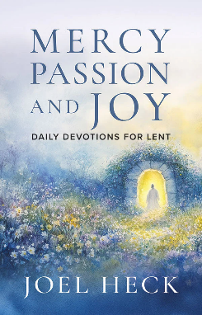
A Lenten Study for 2026 will be offered beginning Tuesday,
February 24 at 10:00 a.m.
We will be using "Mercy, Passion, and Joy: Daily Devotions for Lent" as our guide. This daily devotional booklet for Lent is centered on Scripture and the wisdom of C.S. Lewis, followed by reflections from author Joel Heck. Readers will be led from contemplations on the mercy of Christ, to the Passion he suffered on our behalf, to the astounding joy that is ours because of his great sacrifice for us and Christ's Resurrection. Booklets are available.

We have openings on our 2026 Flower Chart for March 8, 15, 22, as well as many other dates throughout the year. Flowers on the altar is a nice way to honor an anniversary, birthday, or remember a loved one who is no longer with us. Flowers are only $15, and you can drop a check in the offering plate, marking in the memo line, “altar flowers.”
Calling all volunteers! If you would like to assist with helping children with their craft project during Sermontime (usually the second Sunday of the month), please see Diana VanAntwerp or call her at 231.884.1045. More volunteers will mean only an occasional commitment for each of you. Thanks!

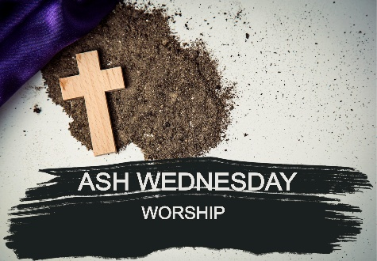
Ash Wednesday — Lent Begins
Join us this Wednesday, February 18 at 7:00 p.m. as we begin a meaningful journey toward the cross and the empty tomb. Ash Wednesday reminds us of God’s mercy, redemption and the hope we have in Jesus. Join us on Wednesday as we gather for reflection, prayer and the imposition of ashes.
Today’s Worship Ministry…………….
Organist/Pianist: Skip Pluger
Liturgist: Deb DeBruyn
Greeters/Ushers: Jack Davis, Dee Brinks
3 dozen cookies (each) for Coffee Hour: MJ VanderHart,
Bob & Beth Garner



Flowers On the Altar Are Given
by Gary Bandelow in Honor of
Yvonne Bandelow’s Birthday on February 17.

The March Volunteer Ministry Sign-Up Sheet for bringing cookies for Coffee Hour is on the food table in Fellowship Hall. Please note, cookies do not have to be homemade! Store-bought work fine, as do donut holes, or cheese and crackers. Remember, volunteers are expected to set up and clean up afterwards. If you have never volunteered for this, please consider doing so.

Your tithes and offerings may be sent directly to the church at P.O. Box 37, Cadillac, MI 49601. If you wish to give online, you may scan the QR code to be connected to "Servant Keeper Online Giving." We thank you for your generosity.



