UNITED METHODIST CHURCH OF CADILLAC
REV. EARL DETWILER
SUNDAY, FEBRUARY 1, 2026

PRELUDE

BRINGING IN THE LIGHT OF CHRIST

WELCOME AND ANNOUNCEMENTS

WITH FAITH, ENTER INTO GOD’S DIVINE PRESENCE

*CALL TO WORSHIP TFWS 2071
“Jesus, Name Above All Names”

*OPENING HYMN UMH 172
“My Jesus, I Love Thee”

*UNISON OPENING PRAYER
Lord, I have lots of questions. Seems like insanity has taken over everything around us. The news is full of situations that really upset us and typically we look for blame. Seeking out our own understanding we become victims of our own thought processes. How can we make sense out of the times we live in? Dear Lord, come to us in this service and establish a presence that will lead us into not just knowledge but understanding. Help us to find direction in your Word and peace in your Spirit. In Jesus name. AMEN.

BY FAITH, WE LOOK INSIDE OUR LIVES

CALL TO REFLECTION

A MOMENT FOR SILENT CONFESSION

PERSONAL TESTIMONY Joel Campbell

BY FAITH, WE SHARE IN THE WORD OF GOD

CHOIR ANTHEM Chancel Choir
“Come Build a Church”
Arr. Ken Medema

SCRIPTURE READING Matthew 5:1-12

SERMON Pastor Earl Detwiler
“Pop Quiz”

BY FAITH, WE RESPOND TO GOD’S CALL

MINISTRY OF PRAYER
Sharing our Joys and Concerns
Pastoral Prayer
The Lord’s Prayer
Our Father, who art in heaven, hallowed be thy name. Thy kingdom come, thy will be done on earth as it is in heaven. Give us this day our daily bread. And forgive us our trespasses, as we forgive those who trespass against us. And lead us not into temptation but deliver us from evil. For thine is the kingdom, and the power, and the glory forever. Amen.

SERVICE OF HOLY COMMUNION
(You may bring your offering forward with you and place it in the offering plate.)
Note: The Choir will be singing “In Remembrance” during communion, therefore please allow them to proceed to the communion rail first.

*Doxology UMH 95
“Praise God, From Whom All Blessings Flow”

*PRAYER OF DEDICATION

WE GO FORTH TO SERVE

*CLOSING HYMN TFWS 2282
“I’ll Fly Away”
*BENEDICTION

*POSTLUDE

UNITED METHODIST CHURCH
OF CADILLAC

February 1, 2026

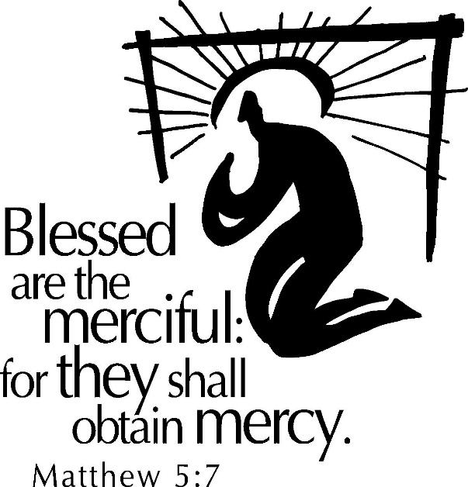

Our Mission
To Lead Everyone in Relationship with Christ.

Our Vision
Bringing people to Christ; developing personal
growth in Christ; putting Christ into action.

