**UNITED METHODIST CHURCH OF CADILLAC**

**REV. KAREN SORDEN**

**SUNDAY, AUGUST 17, 2025**

**PRELUDE**

**BRINGING IN THE LIGHT OF CHRIST**

**WELCOME AND ANNOUNCEMENTS**

**WE GATHER**

**\*HYMN OF BEAUTY UMH 707**

**“Hymn of Promise”**

**\*UNISON OPENING PRAYER**

**Divine Goodness, Holy One, pause us for this moment, bear us up in this time, hold us for eternity. We embrace the brokenness of our lives. We believe you are creating new light that will shine through. We open to your possibilities. Amen.**

**WE PROCLAIM**

**MUSICA DIVINA violín & piano**

**“Melodie”**

**by Gluck/Kreisler**

**LECTIO DIVINA Psalm 147:1-11**

**SERMO DIVINA Pastor Karen Sorden**

**“Awakening to Beauty, Falling in Love with the World”**

@www.worshipdesignstudio.com/beauty

**VISIO DIVINA**

**WE RESPOND**

**MINISTRY OF PRAYER**

**Sharing our Joys and Concerns**

**Pastoral Prayer**

**The Lord’s Prayer**

**Our Father, who art in heaven, hallowed be thy name. Thy kingdom come, thy will be done on earth as it is in heaven. Give us this day our daily bread. And forgive us our trespasses, as we forgive those who trespass against us. And lead us not into temptation, but deliver us from evil. For thine is the kingdom, and the power, and the glory forever. Amen.**

**OFFERING OUR TITHES AND GIFTS TO GOD**

**Offertory**

**\*Doxology**

**\*Prayer of Dedication**

**When we love, O God, we want to give. We would give away our very lives if we loved enough. It is out of our love for you and the world you have made that we turn now to the act of worship through giving. Let these love offerings of our hearts reach out into all the world, saving lives and making life more worthwhile, though Jesus Christ our Lord. Amen.**

**WE GO FORTH**

**RITUAL ACTION**

**\*CLOSING HYMN UMH 400**

**“Come, Thou Fount of Every Blessing”**

**\*BENEDICTION**

**\*POSTLUDE**

@www.worshipdesignstudio.com/beauty

*Thanks to Dorothy Kunkel for providing Special Music*

*for us this morning and*

*Cora McLean for accompanying her on piano*

@www.worshipdesignstudio.com/beauty

**UNITED METHODIST CHURCH**

**OF CADILLAC**

**August 17, 2025**

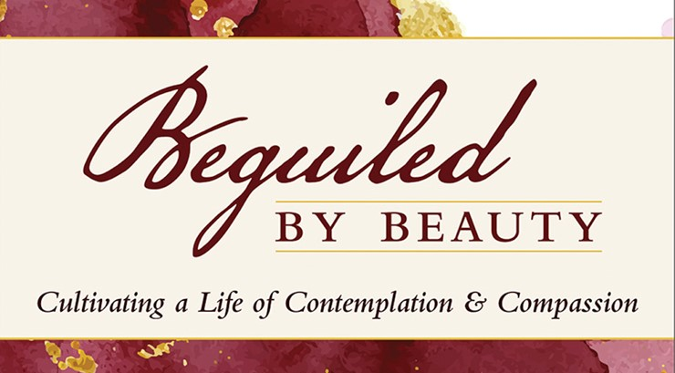

***Our Mission***

*To Lead Everyone in Relationship with Christ.*

***Our Vision***

*Bringing people to Christ; developing personal*

*growth in Christ; putting Christ into action.*