** *Upcoming Birthdays***

August 18 – *Steve Cinco, Reg Klubeck*

August 27 – *Kay Hinkston*

August 30 – *Jim Petersen*

August 31 – *Dick Jones*

Pastor Karen Sorden

Email: [ksorden@sbcglobal.net](mailto:ksorden@sbcglobal.net)

Phone: 231.282.0433

Prayer Requests (email): umccadillac@gmail.com

Church Website: www.cadillacumc.org

Church Email: umccadillac@gmail.com

Church Mailing Address: PO Box 37, Cadillac, MI 49601

Phone: (231) 775.5362

Office Hours: Monday - Thursday 10:00 a.m. - 4:00 p.m.

Pastor Karen’s Office Hours: Monday – Thursday 9:30 am – 1:00 pm

*Closed on Fridays*

**Volunteer Ministry for Sunday, August 24, 2025**

Organist/Pianist: Skip Pluger

Liturgist: Jeff Hinkston

Greeters/Ushers: Jack Davis, Margaret Himes, Kay Hinkston,

Bob Newland

3 dozen cookies (each) for Coffee Hour: Margaret Newland,

Bob & Beth Garner

_____________________________________________________________

**CHURCH STAFF**

Pastor: Rev. Karen Sorden

Office Manager: Diane Coon

Treasurer: Sara Adkin

Choir Director: Reg Klubeck

Organists: Ruth Boonzaaijer, Cora McLean, Skip Pluger,

Dr. Glenn Verbrugge

Nursery: Diana VanAntwerp

***What’s Happening at Church This Week………***

Sunday, August 17

10:30 a.m. – Worship Service

Monday, August 18

3:00 p.m. *– Prayer Group* in Wesley Room

7:00 p.m. – Boy Scouts Troop #125 in Fellowship Hall

Wednesday, August 20

10:30 a.m. – 12:30 p.m. – Weight Loss Group in Corbin Room

7:00 p.m. – *Alcoholics Anonymous* in Corbin Room

Thursday, August 21

3:00 – 5:00 p.m. – *Patriot Choir* in Corbin Room

3:00 – 4:30 p.m. – *Wonderland Humane Society* Mtg in Classroom #1

4:00 – 7:00 p.m. – *Project Christmas* Mtg in Fellowship Hall

Friday, August 22

8:00 p.m. *– Alcoholics Anonymous* in Corbin Room

Sunday, August 24

10:30 a.m. – Worship Service



A Memorial Service for **Fred** **Carrol**l will be held Monday, August 25 at 10:00am here at the church. Visitation will take place on Sunday, August 24 at Peterson Funeral Home from 4:00 – 6:00 pm.

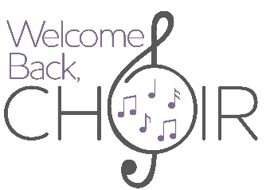

Choir practice will resume on **Wednesday, August 27 at 4:00 p.m.** in the sanctuary.

**Attention Salvation Army Team Members!** Seems like sometimes the best laid plans don’t go as planned! The Salvation Army has hired a full-time cook and now our meal responsibilities have changed. They are asking if we will now supply food ingredients rather than prepared lunches. Our new contact person will be Dolores (231.434.2195), and she is asking for donations of eggs, milk, rolls/bread, fruit, butter, etc. It is suggested you connect with Dolores when your team assignment comes up to finalize their current needs.

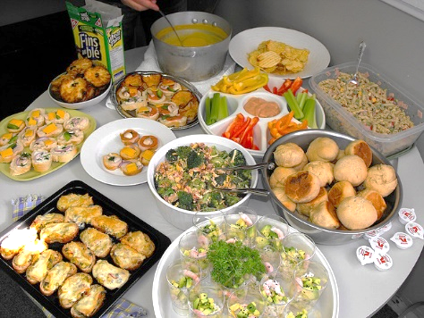

***Potluck Lunch in Honor of***

***Pastor Karen Sorden***

***following worship on***

***September 14.***

**Please join us as we celebrate and honor Pastor Karen for her faithful service these past few years. We will be serving sloppy joes (Pastor Karen’s favorite recipe), and we need you to bring a dish to pass. We don’t need to know *what* you are bringing, but we do need to know *how many of you* are planning on attending. *There is a signup sheet on the Information Center.* You may also call the office (231.775.5362) and leave a message on Diane’s voicemail if she doesn’t answer. Questions? Please contact Dee Brinks at 231.920.8323. We hope to see you there!**

***Today’s Worship Ministry…………….***

Organist/Pianist: Cora McLean

Liturgist: Judy Houts

**Greeters/Ushers:** Jack Davis, Char Butterfield, Dan & Sue Nelson,

Jerry Deer

3 dozen cookies (each) for Coffee Hour: Carol George, Dee Brinks

 **Flowers On the Altar Are Given in**

**Honor of Donna McCormick’s Birthday on August 15**

**from Donna’s Children and by Steve & Joyce Cinco**

**in Honor of Their 56th Wedding Anniversary on August 20.**

***Welcome, friends – new and familiar! The psalmist reminds us: “This is the day the Lord has made; let us rejoice and be glad in it.” (Psalm 118:24) May our hearts be open today to God’s presence, peace, and purpose.***

**The August Volunteer Ministry Sign-Up Sheet for bringing cookies for Coffee Hour i**s on the food table in Fellowship Hall. Thank you to those who have already signed up. ***We still need 1 individual/family for August 31.*** Remember, volunteers are expected to set up and clean up afterwards. If you have never volunteered for this, please consider doing so.

**Your tithes and offerings may be sent directly to the church at P.O. Box 37, Cadillac, MI 49601. If you wish to give online, you may scan the QR code to be connected to "Servant Keeper Online Giving." We thank you for your generosity.**