** *Upcoming Birthdays***

July 7 *– Ruth Conradson*

July 9 *– Barb Tatarchuk*

July 13 *– Harry Wilson, Dan Zenner*

July 14 *– Beth Garner*

Pastor Karen Sorden

Email: [ksorden@sbcglobal.net](mailto:ksorden@sbcglobal.net)

Phone: 231.282.0433

Prayer Requests (email): umccadillac@gmail.com

Church Website: www.cadillacumc.org

Church Email: umccadillac@gmail.com

Church Mailing Address: PO Box 37, Cadillac, MI 49601

Phone: (231) 775.5362

Office Hours: Monday - Thursday 10:00 a.m. - 4:00 p.m.

Pastor Karen’s Office Hours: Monday – Thursday 9:30 am – 1:00 pm

*Closed on Fridays*

**Volunteer Ministry for Sunday, July 13, 2025**

Organist/Pianist: Ruth Boonzaaijer

Liturgist: Diane Wilkinson

Greeters/Ushers: Jack Davis, Dee Brinks, MJ VanderHart,

Dan & Sue Nelson

3 dozen cookies (each) for Coffee Hour: Diana Detwiler, Carol Nelson

_____________________________________________________________

**CHURCH STAFF**

Pastor: Rev. Karen Sorden

Office Manager: Diane Coon

Treasurer: Sara Adkin

Choir Director: Reg Klubeck

Organists: Ruth Boonzaaijer, Cora McLean, Skip Pluger,

Dr. Glenn Verbrugge

Nursery: Diana VanAntwerp

***What’s Happening at Church This Week………***

Sunday, July 6

10:30 a.m. – Worship Service w/Holy Communion

Monday, July 7

3:00 p.m. *– Prayer Group* in Wesley Room

7:00 p.m. – Boy Scouts Troop #125 in Fellowship Hall

Tuesday, July 8

12:00 Noon – Ladies Lunch in Fellowship Hall

12:00 Noon – Mens Lunch in Corbin Room

5:30 – 7:00 p.m. – *Refuge Church* Begins Their Tuesday evening VBS

which runs through August 5, using kitchen & FH

Wednesday, July 9

10:30 a.m. – 12:30 p.m. – Weight Loss Group in Corbin Room

7:00 p.m. – *Alcoholics Anonymous* in Corbin Room

Thursday, July 10

3:00 – 5:00 p.m. – *Patriot Choir* in Corbin Room

Friday, July 11

8:00 p.m. *– Alcoholics Anonymous* in Corbin Room

Sunday, July 13

10:30 a.m. – Worship Service

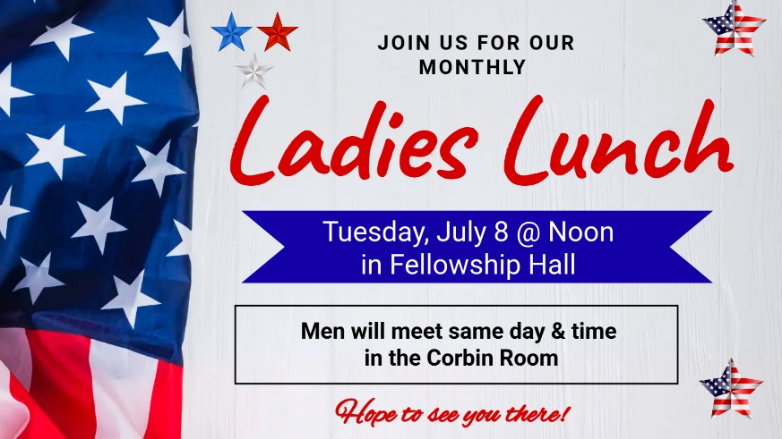

**Play ball!** We are once again attending a **Pit Spitters ball game** in Traverse City on July 23 at 7:00 pm. They will be playing against the Rockford Rivets. Tickets are $14 each. A signup sheet is available at the Information Center.

Questions? Please speak with Jerry Deer.

**The food distribution for July** will go to the *Salvation Army* Food Pantry. They can use shelf milk, boxed potatoes, mac & cheese, soups (*please, no* *mushroom soup*), cereal, tuna and any other non-perishable food items. Please place your donations in the food storage container located between the double front doors. Thank you for your generosity.

**The July Volunteer Ministry Sign-Up Sheet** for bringing cookies for Coffee Hour is on the food table in Fellowship Hall. Thank you to those who have already signed up. **We still need 1 individual/family for July 20, and 1 for July 27.** Remember, volunteers are expected to set up and clean up afterwards. If you have never volunteered for this, please consider doing so.



**On Sunday, September 14 following worship service we will have a farewell celebration for Pastor Karen.** More details will follow in the coming weeks. But mark your calendars now so you don’t miss this event.



We are in need of expanding our usher/greeter volunteer list. If you would be willing to serve in this capacity, please speak with Dee Brinks or phone her at 231.920.8323.

***Today’s Worship Ministry…………….***

Organist/Pianist: Skip Pluger

Liturgist: Laurie Kinney

**Greeters/Ushers:** Jack Davis, Diana VanAntwerp, Sheryl Blanchard,

Margaret Himes

3 dozen cookies (each) for Coffee Hour: Sheryl Blanchard, Judy Davis



**Flowers On the Altar Are Given by**

**Dan & Sue Nelson in Remembrance**

**of the hard-fought struggles and sacrifices made by our founding fathers and others in the pursuit of freedom.**

Our **Loose Plate Offering** for July will go to the Pastors Discretionary Fund.

Our Pastor's Discretionary Fund allows our Pastor to provide emergency financial aid to someone in need within our congregation or community. Working within the parameters of our Financial Policies, this Fund allows our Pastor to quickly help someone without having to go through the normal approval process. For instance, if someone walks into the church off the street asking for help with bus fare, gasoline, a hotel room, etc., our Pastor has the discretion to help them utilizing this fund. Thank you for your consistant generosiity. If you wish to write a check, please note in the memo line: *July Loose Plate*.

**Your tithes and offerings may be sent directly to the church at P.O. Box 37, Cadillac, MI 49601. If you wish to give online, you may scan the QR code to be connected to "Servant Keeper Online Giving." We thank you for your generosity.**