** Upcoming Birthdays**

June 23 – *Lucas Enyeart*

June 26 – *Margaret Himes*

June 27 – *Bob Everett, Lindsey Fuller*

July 1 *– Irene Gladding*

Pastor Karen Sorden

Email: [ksorden@sbcglobal.net](mailto:ksorden@sbcglobal.net)

Phone: 231.282.0433

Prayer Requests (email): umccadillac@gmail.com

Church Website: www.cadillacumc.org

Church Email: umccadillac@gmail.com

Church Mailing Address: PO Box 37, Cadillac, MI 49601

Phone: (231) 775.5362

Office Hours: Monday - Thursday 10:00 a.m. - 4:00 p.m.

Pastor Karen’s Office Hours: Monday – Thursday 9:30 am – 1:00 pm

*Closed on Fridays*

**Volunteer Ministry for Sunday, June 29, 2025**

Organist/Pianist: Dr, Glenn Verbrugge

Liturgist: Diane Wilkinson

Greeters/Ushers: *Open*

3 dozen cookies (each) for Coffee Hour: Dee Brinks, Mary Buehler

_____________________________________________________________

**CHURCH STAFF**

Pastor: Rev. Karen Sorden

Office Manager: Diane Coon

Treasurer: Sara Adkin

Choir Director: Reg Klubeck

Organists: Ruth Boonzaaijer, Cora McLean, Skip Pluger,

Dr. Glenn Verbrugge

Nursery: Diana VanAntwerp

***What’s Happening at Church This Week………***

Sunday, June 22

10:30 a.m. – Worship Service

12:00 – 4:00 p.m. – Fund-Raising Car Show to Benefit *Freedom Festival*

Monday, June 23

3:00 p.m. *– Prayer Group* in Wesley Room

7:00 p.m. – Boy Scouts Troop #125 in Fellowship Hall

Wednesday, June 25

10:00 a.m. – *Ministry Team Leaders* Meeting in Fellowship Hall w/Pastor Karen

10:30 a.m. – 12:30 p.m. – Weight Loss Group in Corbin Room

7:00 p.m. – *Alcoholics Anonymous* in Corbin Room

Friday, June 27

8:00 p.m. *– Alcoholics Anonymous* in Fellowship Hall

Sunday, June 29

10:30 a.m. – Worship Service

12:00 Noon. – *Church Unique* Meeting following worship service

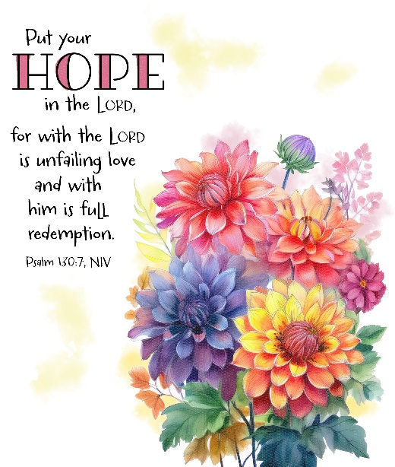

**Thank you** can’t even begin to express the gratitude that our family is feeling about our church family. So many of you gave so much of yourselves in an effort to provide comfort and peace to us in the passing of our mother Peg Steward. The hospitality extended by welcoming, consoling and providing food and drink to those who celebrated her life was incredible. It was an extension of the United Methodist values we all share. We, as a family, are most grateful.

Yours in Christ, *Beth Garner* on behalf of the entire Steward/Garner family

**We have openings on our Flower Chart** for August 24, September 7, October 12 & 19, November 2 & 30 and December 7**.**  Flowers on the altar is a nice way to honor an anniversary, birthday, or remember a loved one who is no longer with us. Flowers are only $15, and you can drop a check in the offering plate marking in the memo line, “altar flowers.”

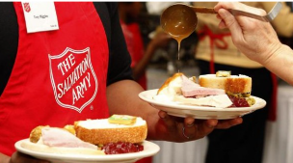Can you believe it?!! Wow! **We are looking at beginning our 3rd round of providing lunches for the homeless through the Salvation Army.** That means it is also time to decide if you plan to continue as a volunteer for this VERY important outreach program. If you plan to continue as a team member, you do NOT have to do ANYTHING! You will be assigned as a team to your new time and you will receive updated information. If, for whatever reason, you choose not to continue, please connect by phone or text with Margaret Newland at 231.631.6818 *before* June 29, so your name can be removed from the list. Also, if you think you might be interested in being a part of this great outreach program, let Margaret know so you can be added to the list of volunteers. There are presently 8 teams of 4 participating, to provide a lunch once a month………, so, as you can see, it is NOT a big investment of time or money, yet it means so much to people suffering from food insecurities. Thank you to all who have so faithfully and generously supported this program – you are APPRECIATED!

***Today’s Worship Ministry…………….***

Organist/Pianist: Cora McLean

Liturgist: Judy Coffey

**Greeters/Ushers:** Jack Davis, Margaret Himes, Kay Hinkston

Bob Newland

3 dozen cookies (each) for Coffee Hour: Carol Nelson, Lark Miller



**Flowers On the Altar Are Given by**

**Dave & Sally Bassett in Honor of**

**Their 55th Wedding Anniversary on June 27.**

**The July Volunteer Ministry Sign-Up Sheet for bringing cookies for Coffee Hour is on the food table in Fellowship Hall.** Remember, volunteers are expected to set up and clean up afterwards. If you have never volunteered for this, please consider doing so.

**Play ball!** We are once again attending a **Pit Spitters ball game** in Traverse City on July 23 at 7:00 pm. They will be playing against the Rockford Rivets. Tickets are $14 each. A signup sheet is available at the Information Center.

Questions? Please speak with Jerry Deer.

**Your tithes and offerings may be sent directly to the church at P.O. Box 37, Cadillac, MI 49601. If you wish to give online, you may scan the QR code to be connected to "Servant Keeper Online Giving." We thank you for your generosity.**