** Upcoming Birthdays**

June 18 – *Ryan Bruner*

June 19 – *Bob Newland*

June 20 – *Dewayne Richard*

June 23 – *Lucas Enyeart*

Pastor Karen Sorden

Email: [ksorden@sbcglobal.net](mailto:ksorden@sbcglobal.net)

Phone: 231.282.0433

Prayer Requests (email): umccadillac@gmail.com

Church Website: www.cadillacumc.org

Church Email: umccadillac@gmail.com

Church Mailing Address: PO Box 37, Cadillac, MI 49601

Phone: (231) 775.5362

Office Hours: Monday - Thursday 10:00 a.m. - 4:00 p.m.

Pastor Karen’s Office Hours: Monday – Thursday 9:30 am – 1:00 pm

*Closed on Fridays*

**Volunteer Ministry for Sunday, June 22, 2025**

Organist/Pianist: Cora McLean

Liturgist: Judy Coffey

Greeters/Ushers: Jack Davis, Margaret Himes, Kay Hinkston

Bob Newland

3 dozen cookies (each) for Coffee Hour: Carol Nelson, Lark Miller

_____________________________________________________________

**CHURCH STAFF**

Pastor: Rev. Karen Sorden

Office Manager: Diane Coon

Treasurer: Sara Adkin

Choir Director: Reg Klubeck

Organists: Ruth Boonzaaijer, Cora McLean, Skip Pluger,

Dr. Glenn Verbrugge

Nursery: Diana VanAntwerp

***What’s Happening at Church This Week………***

Sunday, June 15 – Father’s Day

10:30 a.m. – Worship Service

Monday, June 16

9:00 a.m. – 3:00 p.m. – Senior Volunteer Programs of NWMI mtg in FH

3:00 p.m. – Prayer Group in Wesley Room

7:00 p.m. – Boy Scouts Troop #125 in Fellowship Hall

Wednesday, June 18

10:30 a.m. – 12:30 p.m. – Weight Loss Group in Corbin Room

7:00 p.m. – *Alcoholics Anonymous* in Corbin Room

Thursday, June 19

3:00 – 5:00 p.m. – *Patriot Choir* Dress Rehearsal in Sanctuary

Friday, June 20

6:30 p.m. – *Patriot Choir* Summer Program & Bakesale

8:00 p.m. *– Alcoholics Anonymous* in Classroom #1

Sunday, June 22

10:30 a.m. – Worship Service

12:00 – 4:00 p.m. – Fund-Raising Car Show to Benefit *Freedom Festival*

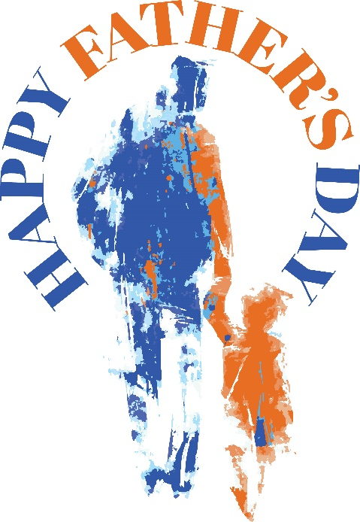

**Do you have a key FOB you are no longer using? We are in desperate need of increasing the key FOBS we have on hand.** We realize that many of you most likely have one, and have not had a need to get into the church beyond normal office hours. Would you please consider returning it, if you have one? We can no longer order the FOBS, as they are only available in quentities of 50, at a cost of $450. If you are willing and able, please contact Diane in the office to return yours.

**Randy Myers is looking for individuals/groups to do special music on Sundays throughout the summer,** when the choir is on hiatus. If this is something you are interested in doing, please email Diane in the church office ([umccadillac@gmail.com](mailto:umccadillac@gmail.com))

**A few people have asked if Game Night could continue throughout the summer.** I have no idea how many would attend. We could play weekly or biweekly. If you would be interested in attending Game Night throughout the summer, please contact Jane Kielbasa at kielbasa.jane@gmail.com or leave her a voice message at 231.730.4934.

**We have openings on our Flower Chart** for August 24, September 7, October 12 & 19, November 2 & 30 and December 7**.**  Flowers on the altar is a nice way to honor an anniversary, birthday, or remember a loved one who is no longer with us. Flowers are only $15, and you can drop a check in the offering plate marking in the memo line, “altar flowers.”

Dear Church Family: Thank you for honoring me as a High School graduate. I appreciate your thoughts and prayers. Thank you for the football blanket and Bible too. Go Cats! *Kyle McGowan*

***Today’s Worship Ministry…………….***

Organist/Pianist: Skip Pluger

Liturgist: Yvonne Bandelow

**Greeters/Ushers:** Jack Davis, Char Butterfield, Dan & Sue Nelson,

Jerry Deer

3 dozen cookies (each) for Coffee Hour: Jean Lakin, Kay Hinkston



**Flowers On the Altar Are Given by**

**Sherly Blanchard In Loving Memory of**

**Bernadean Gregg**

The June Volunteer Ministry Sign-Up Sheet for bringing cookies for Coffee Hour is on the food table in Fellowship Hall. ***We need still need one indivdiual or family for June 29.*** If you have never volunteered for this, please consider doing so. Remember, volunteers are expected to set up and clean up afterwards.

**Next Sunday, June 22, from 12:00 – 4:00 pm is our Car Show fund-raiser for Freedom Festival,** here at the church. If you would like to help with this event, signup sheets for a variety of positions are available on the Information Center.

**Your tithes and offerings may be sent directly to the church at P.O. Box 37, Cadillac, MI 49601. If you wish to give online, you may scan the QR code to be connected to "Servant Keeper Online Giving." We thank you for your generosity.**