** Upcoming Birthdays**

*Char Butterfield* – April 30

*June Parmenter* – May 7

*Alex McGowan* – May 12

*Chris Selby* – May 14

Pastor Karen Sorden

Email: [ksorden@sbcglobal.net](mailto:ksorden@sbcglobal.net)

Phone: 231.282.0433

Prayer Requests (email): umccadillac@gmail.com

Church Website: www.cadillacumc.org

Church Email: umccadillac@gmail.com

Church Mailing Address: PO Box 37, Cadillac, MI 49601

Phone: (231) 775.5362

Office Hours: Monday - Thursday 10:00 a.m. - 4:00 p.m.

Pastor Karen’s Office Hours: Monday – Thursday 9:30 am – 1:00 pm

*Closed on Fridays*

**Volunteer Ministry for Sunday, May 4, 2025**

Organist/Pianist: Skip Pluger

Liturgist: Laurie Kinney

Greeters/Ushers: Jack Davis, Diana VanAntwerp, Sheryl Blanchard,

Margaret Himes

3 dozen cookies (each) for Coffee Hour: Lark Miller, Judy Davis

_____________________________________________________________

**CHURCH STAFF**

Pastor: Rev. Karen Sorden

Office Manager: Diane Coon

Treasurer: Sara Adkin

Choir Director: Reg Klubeck

Organists: Ruth Boonzaaijer, Cora McLean, Skip Pluger,

Dr. Glenn Verbrugge

Nursery: Diana VanAntwerp

***What’s Happening at Church This Week………***

Sunday, April 27 – 2nd Sunday of Easter

10:30 a.m. – Worship Service

12:00 p.m. – *Church Unique* Team w/ Jim Noggle in Fellowship Hall

Monday, April 28

3:00 p.m. – Prayer Group in Wesley Room

5:00 p.m. – *Gospel Guitar Group* in Corbin Room

7:00 p.m. – Boy Scouts Troop #125 in Fellowship Hall

Wednesday, April 30

10:30 a.m. – 12:30 p.m. – Weight Loss Group in Corbin Room

1:00 – 3:00 p.m. – Small Meeting in Corbin Room

5:00 p.m. – Game Night in Fellowship Hall

7:00 p.m. – Choir Practice in Sanctuary

7:00 p.m. – *Alcoholics Anonymous* in Corbin Room

Thursday, May 1 – National Day of Prayer

3:00 – 5:00 p.m. – *Patriot Choir* in Corbin Room

4:30 – 7:30 p.m. – 4H/Jam & Bread in Educ. Wing/Kitchen/Fellowship Hall

Friday, May 2

8:00 p.m. *– Alcoholics Anonymous* in Corbin Room

Sunday, May 4 – 3rd Sunday of Easter

Blood Pressure Clinic before & after Service

10:30 a.m. – Worship Service w/Holy Communion

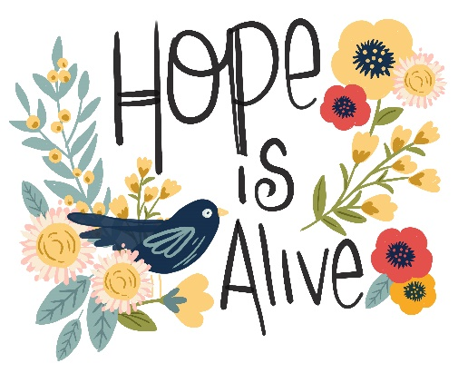

**Our Loose Plate Offering for May** will go to the offering taken at our Annual Conference. The traditional opening worship offering at Annual Conference this year (May 29-June 1) will benefit two longstanding mission partners of the Michigan Conference: the people of Haiti and the Liberia Annual Conference. Bishop Bard has designated a 10% tithe of the offering received go to UMCOR US Disaster Response and Recovery, most recently addressing devastation from Hurricane Helene on the East Coast, and the California wildfires. If you would like to write a check, please write in the memo line: *May Loose Plate*.

**The food distribution for May** will go to the Mesick Methodist Food Pantry. They can use canned fruit, canned pasta, peanut butter, cereal, macaroni and cheese and any non-perishable food items. Please place your donations in the food storage container located between the double front doors. Thank you for your generosity.

**We have openings on our 2025 Flower Chart** for May 25, June 1, 15 & 29 and July 6, 13 and 27, as well as other dates throughout the year.Flowers on the altar is a nice way to honor an anniversary, birthday, or remember a loved one who is no longer with us. Flowers are only $15, and you can drop a check in the offering plate marking in the memo line, “altar flowers.”

**Volunteers Needed!**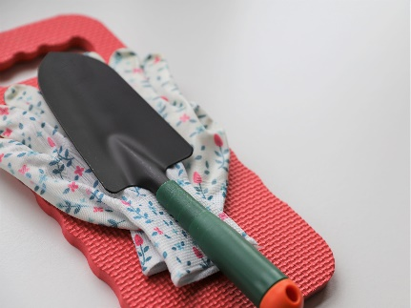

Sheryl Blanchard is looking for volunteers this summer to clean the flower beds of both the **Peace Garden and Memorial Garden.** You can call Sheryl directly (231.920.9897) to sign up or for her to answer any questions you may have.

***Today’s Worship Ministry…………….***

Organist/Pianist: Cora McLean

Liturgist: Bob Garner

**Greeters/Ushers:** Jack Davis, Margaret Himes, Kay Hinkston,

Bob Newland

3 dozen cookies (each) for Coffee Hour: Floy Nostrant, MJ VanderHart

Providing a cake in honor of their wedding anniversary:

Bob & Linda Everett



**Flowers on the Altar are Given by**

**Dee Brinks in Honor of Mike Brinks Birthday on April 21**

**and by Bob & Linda Everett in Honor of Their**

**59th Wedding Anniversary on April 30 and by**

**Gale Butterfield in Honor of Charlotte Butterfield’s**

**Birthday on April 30.**

On the food table in Fellowship Hall is the signup sheet for **May’s Coffee Hour**. **We need two individuals each for May 11 and May 25.** Thank you so much to those who have volunteered. If you’ve never volunteered for this, please consider doing so. Remember, volunteers are expected to set up and clean up afterwards.

