** Upcoming Birthdays**

March 26 – Randy Myers, Eileen Richard,

June Taylor

Pastor Karen Sorden

Email: [ksorden@sbcglobal.net](mailto:ksorden@sbcglobal.net)

Phone: 231.282.0433

Prayer Requests (email): umccadillac@gmail.com

Church Website: www.cadillacumc.org

Church Email: umccadillac@gmail.com

Church Mailing Address: PO Box 37, Cadillac, MI 49601

Phone: (231) 775.5362

Office Hours: Monday - Thursday 10:00 a.m. - 4:00 p.m.

Pastor Karen’s Office Hours: Monday – Thursday 9:30 am – 1:00 pm

*Closed on Fridays*

**Volunteer Ministry for Sunday, March 30, 2025**

Organist/Pianist: Cora McLean

Liturgist: Diane Wilkinson

**Greeters/Ushers: Open**

3 dozen cookies (each) for Coffee Hour: Judy Helsel, Margaret Newland

_____________________________________________________________

**CHURCH STAFF**

Pastor: Rev. Karen Sorden

Office Manager: Diane Coon

Treasurer: Sara Adkin

Choir Director: Reg Klubeck

Organists: Ruth Boonzaaijer, Cora McLean, Skip Pluger,

Dr. Glenn Verbrugge

Nursery: Diana VanAntwerp

***What’s Happening at Church This Week………***

Sunday, March 23 –Third Sunday in Lent

10:30 a.m. – Worship Service

Monday, March 24

3:00 p.m. – Prayer Group in Wesley Room

5:00 p.m. – *Gospel Guitar Group* in Corbin Room

Tuesday, March 25

10:00 a.m. – Lenten Bible Study in Fellowship Hall

Wednesday, March 26

10:30 a.m. – 12:30 p.m. – Weight Loss Group in Corbin Room

5:00 p.m. – Game Night in Fellowship Hall

7:00 p.m. – Choir Practice in Sanctuary

7:00 p.m. – *Alcoholics Anonymous* in Corbin Room

Thursday, March 27

3:00 – 5:00 p.m. – *Patriot Choir* in Corbin Room

Friday, March 28

8:00 p.m. *– Alcoholics Anonymous* in Corbin Room

Sunday, March 30 – Fourth Sunday in Lent – UMCOR Sunday

10:30 a.m. – Worship Service

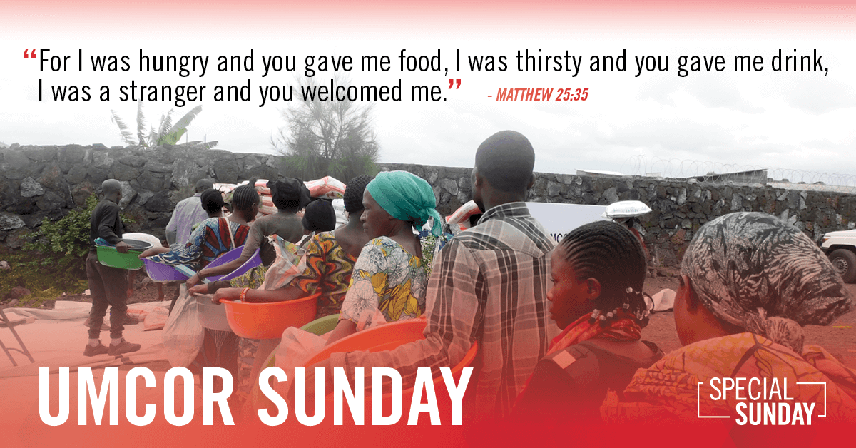

**UNITED METHODIST COMMITTEE**

**ON RELIEF (UMCOR) SUNDAY**

**MARCH 30, 2025**

Gifts given on UMCOR Sunday play a vital role in enhancing the church's global humanitarian response because these funds cover UMCOR's administrative costs.

This support ensures that 100% of donations given to UMCOR throughout the year can be directed toward on-the-ground relief and recovery efforts, allowing UMCOR to effectively respond to crises and provide assistance where it's needed most.

Envelopes will be available on March 30.

The **AMEN Chorus** will begin rehearsals Saturday, April 5, at the Cadillac Christian Reformed Church from 6:00-8:00 P.M.  If you are a gentleman that loves to sing, we invite you to join this fantastic group. Our program will be held on Sunday, May 11. Please bring $10 to the first rehearsal to help cover the cost of music.   If you have any questions, you can contact Angela Warner at [kirkangelawarner@hotmail.com](mailto:kirkangelawarner@hotmail.com) or 231-330-0894.

***Today’s Worship Ministry…………….***

Organist/Pianist: Dr. Glenn Verbrugge

Liturgist: Judy Houts

**Greeters/Ushers:** Jack Davis, Margaret Himes, Kay Hinkston, Bob Newland

3 dozen cookies (each) for Coffee Hour: Linda Campbell, Kay Hinkston

**Flowers on the Altar are Given**

**by Bob & Margaret Newland**

**In honor of their Grandsons’,**

**Connor & Ryan, Birthdays.**

On the food table in Fellowship Hall is the signup sheet for **April’s Coffee Hour**. **We need two individuals for each Sunday.** Thank you so much to those who have already volunteered. If you’ve never volunteered for this, please consider doing so. Remember, volunteers are expected to setup and cleanup afterwards.

**We have openings on our 2025 Flower Chart for March 30** as well as many other dates throughout the year. Flowers on the altar is a nice way to honor an anniversary, birthday, or remember a loved one who is no longer with us. Flowers are only $15, and you can drop a check in the offering plate marking in the memo line, “altar flowers.”

**Our Loose Plate Offering for March** will go to *Vets Serving Vets* to purchase perishable food items such as meat, fresh fruits, and vegetables. Thank you for your consistent generosity. If you would like to write a check, please write in the memo line: *March Loose Plate*.

**The food distribution for March will go to the New Hope Center.** They can use: coffee and non-dairy creamer, grab-n-go snacks, Miracle Whip, small juice boxes, grab-n-go breakfast foods, *i.e.* granola bars, Pop Tarts, etc. Please place your donations in the food storage container located between the double front doors. Thank you for your generosity.