UNITED METHODIST CHURCH OF CADILLAC
REV. KAREN SORDEN
SUNDAY, MARCH 23, 2025
THIRD SUNDAY IN LENT
“THE CUP YOU CHOOSE”
PRELUDE

BRINGING IN THE LIGHT OF CHRIST

WELCOME AND ANNOUNCEMENTS

WE ENTER INTO GOD’S DIVINE PRESENCE

*CALL TO WORSHIP (congregation in bold)
God, we choose you! Our hearts are glad! Our whole bodies shout for joy and rest in you.
God, we choose you when good things are happening and joy can easily be found.
We choose you when our thoughts trouble us and we can’t find sleep.
God, you are our cup of blessing and you hold our futures.
We bless you because you are our Counselor, Guide, and the One who secures us.
God, we choose you! Our hearts are glad! Our whole bodies shout for joy and rest in you.

*OPENING HYMN “Jesus Is All the World to Me” UMH 469

*UNISON OPENING PRAYER
Almighty God, we praise your holy name. You have chosen us as your people and in return we love you and it’s our desire to know you more. Give us a thirst for you that we may choose nothing less than to become like Jesus. In the wonderful and powerful name of Jesus Christ we pray. Amen.

WE CONFESS OUR SINS TO GOD

CALL TO CONFESSION

UNISON PRAYER OF CONFESSION
God of Truth and Grace, forgive us when we are tempted to turn to the many false gods out there, gods like politics, vanity, consumerism, achievement, or constant satisfaction. You are the Lord of Lords, our True North, our First Love. Help us place you at the center of our thoughts, discover you to be the ground beneath our walking, and stand firm in you as the foundation on which we build our lives. Forgive us, quench us, make us whole, all in the name of Jesus. Amen.

A MOMENT FOR SILENT CONFESSION

ASSURANCE OF FORGIVENESS (congregation in bold)
The Lord is our chosen portion and our cup.
God binds us in, counsels our minds, and instructs our hearts.
God helps us to stand firm for justice, mercy, and peace.
When we fall, God lifts us up, forgives us, and remembers our sins no more. Thanks be to God! Amen.

WE HEAR GOD’S WORD PROCLAIMED

SPECIAL MUSIC “In Christ Alone” Megan Leineke
by K. Getty & S. Townend (CCLI #3350395)

SCRIPTURE READING – Psalm 16

SERMON “The Cup You Choose” Rev. Karen Sorden

WE RESPOND IN JOYFUL SERVICE

*HYMN OF RESPONSE “I Am Thine, O Lord” UMH 419

MINISTRY OF PRAYER
Sharing our Joys and Concerns
Pastoral Prayer
The Lord’s Prayer
Our Father, who art in heaven, hallowed be thy name. Thy kingdom come, thy will be done on earth as it is in heaven. Give us this day our daily bread. And forgive us our trespasses, as we forgive those who trespass against us. And lead us not into temptation, but deliver us from evil. For thine is the kingdom, and the power, and the glory forever. Amen.

OFFERING OUR TITHES AND GIFTS TO GOD
Offertory
*Doxology “Praise God, from Whom All Blessings Flow” UMH 95
*Unison Prayer of Dedication
When we turn our lives to you, O God, we find ourselves enrolled in your sacred story, becoming participants in the work of salvation. With open hands we offer to you our tithes and gifts, so that all your children may come to declare “the boundary lines have fallen for me in pleasant places.” Amen.

WE GO FORTH TO SERVE

*CLOSING HYMN “God Will Take Care of You” UMH 130

*BENEDICTION

*POSTLUDE

WELCOME TO
UNITED METHODIST CHURCH
OF CADILLAC

March 23, 2025
Third Sunday in Lent

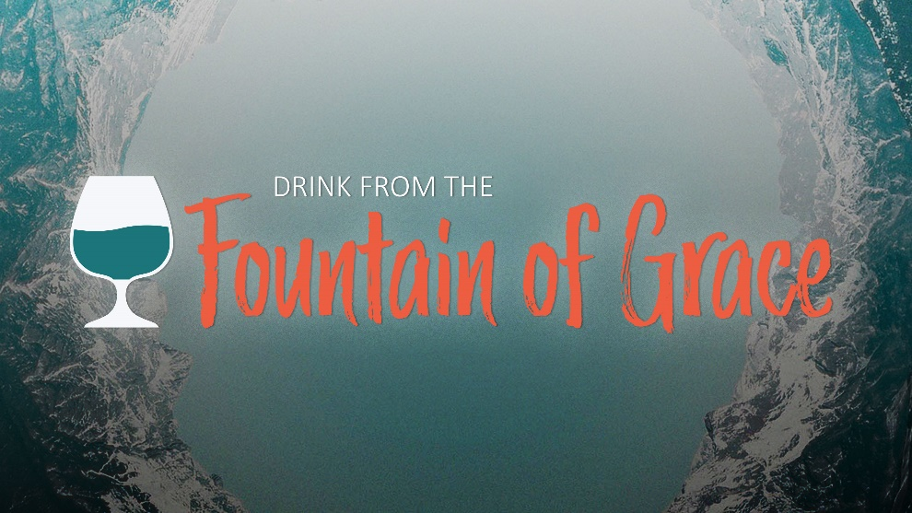

“The Cup You Choose”
Psalm 16

Our Mission
To Lead Everyone in Relationship with Christ.

Our Vision
Bringing people to Christ; developing personal
growth in Christ; putting Christ into action.

