UNITED METHODIST CHURCH OF CADILLAC
REV. KAREN SORDEN
SUNDAY, DECEMBER 15, 2024
ADVENT III – A HOME FOR ALL (JOY)

PRELUDE

BRINGING IN THE LIGHT OF CHRIST

WELCOME AND ANNOUNCEMENTS

WE ENTER INTO GOD’S DIVINE PRESENCE

*CALL TO WORSHIP (congregation in bold)
A voice calls out in the wilderness.
It sings of a home for all. It speaks of justice and peace.
We could choose to ignore it.
We could drown out that song. We could choose not to listen.
Instead, we come into this space.
We let the world grow quiet. We listen.
A voice calls out in the wilderness. Do you hear it?
We hear it. In listening, we worship.
Let us draw near to God.

*OPENING HYMN UMH 203
“Hail to the Lord’s Anointed”

LIGHTING THE ADVENT CANDLE OF JOY

Song: “Make of My Heart A Stable” See Song Sheet in Pew Rack

WE CONFESS OUR SINS TO GOD

CALL TO CONFESSION

UNISON PRAYER OF CONFESSION
Expansive God, We know that the church is your house, and your house has room for everyone. Yet, too often, instead of setting the table for our neighbors, we block the door. Instead of welcoming all, we judge others by our own standards. Instead of sharing our second coat, we hide it in the attic, holding on to fear instead of letting go with love. Remind us that your home is a home for all, that truth requires hard work, that truth requires uncomfortable justice. Help us to be bold enough to see it and brave enough to live it. With hope we pray. Amen.

A MOMENT FOR SILENT CONFESSION

ASSURANCE OF FORGIVENESS (congregation in bold)
Family of faith, God sent prophets like John the Baptist to us because this work is not easy. Helping create a world where all might have a home, and all might be loved, and all might know peace, is an audacious goal. Fortunately for us, when we mess up—when we lose our way or forget our call—we are met with grace. God could not love us any more or any less than God already does. So, rest in this good news:
We are at home with God—forgiven, claimed, and loved. The door is always
open for us. Thanks be to God. Amen.

WE HEAR GOD’S WORD PROCLAIMED

CHOIR ANTHEM Chancel Choir
“Arise & Shine! Your light Has Come!”
Arr. by Joseph M. Martin

SCRIPTURE READING Luke 3:1-18

SERMON Pastor Karen Sorden
“A Home for All”

WE RESPOND IN JOYFUL SERVICE

*HYMN OF RESPONSE See Insert
“A Home for All” (to the tune of Hark! The Hearld Angles Sing, UMH 240)

MINISTRY OF PRAYER
Sharing our Joys and Concerns
Pastoral Prayer
The Lord’s Prayer
Our Father, who art in heaven, hallowed be thy name. Thy kingdom come, thy will be done on earth as it is in heaven. Give us this day our daily bread. And forgive us our trespasses, as we forgive those who trespass against us. And lead us not into temptation, but deliver us from evil. For thine is the kingdom, and the power, and the glory forever. Amen.

Prayer Response “O Little Town of Bethlehem” v.4 UMH 230

OFFERING OUR TITHES AND GIFTS TO GOD
Offertory
*Doxology (To the tune of “The First Noel”) UMH 245
Praise God from whom all blessings flow.
Praise God, all creatures here below.
Praise God above, ye heavenly host.
Praise Father, Son, and Holy Ghost.
Noel, Noel, Noel, Noel,
born is the King of Israel.

*Unison Prayer of Dedication
God who welcomes us home, who creates space, who leaves a chair with our
name on it— we have two coats and we are giving one away. That’s what this offering is. It’s our second coat. It’s our hearts on our sleeves. It’s our
audacious hope that there can indeed be a better world than this one. So, take these gifts and use them to move us closer to that promised day. Gratefully we pray. Amen.
WE GO FORTH TO SERVE

*CLOSING HYMN UMH 211
“O Come, O Come, Emmanuel”

*BENEDICTION

*POSTLUDE

UNITED METHODIST CHURCH
OF CADILLAC

December 15, 2024

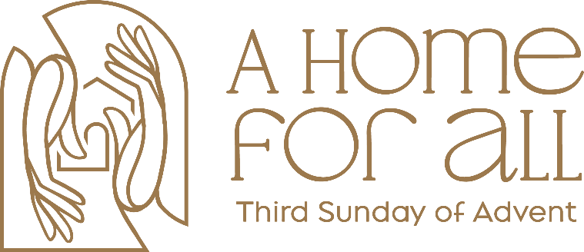

Our Mission
To Lead Everyone in Relationship with Christ.

Our Vision
Bringing people to Christ; developing personal
growth in Christ; putting Christ into action.

“A Home for All”

(to the tune of “Hark the Herald Angels Sing”)
Lyrics by Anna Strickland, A Sanctified Art, LLC, anctifiedart.org (used with permission)

vs. 1
Light the candles, deck the halls
We are making room for all
Practice hospitality
Give in Christian charity
But to create lasting change
A transactional exchange
Won’t make straight our crooked ways
Or lift valleys into plains
Prophets of the ages call:
“We must build a home for all!”

vs. 2
Stack the gifts beneath the tree
Hang the lights where all can see
Send cards full of Christmas cheer
To the family far and near
But the greatest gift we share
Is a world that’s just and fair
Though it feels so far away
We work for God’s promised day
Prophets of the ages call:
“We must build a home for all!”

“A Home for All”

(to the tune of “Hark the Herald Angels Sing”)
Lyrics by Anna Strickland, A Sanctified Art, LLC, anctifiedart.org (used with permission)

vs. 1
Light the candles, deck the halls
We are making room for all
Practice hospitality
Give in Christian charity
But to create lasting change
A transactional exchange
Won’t make straight our crooked ways
Or lift valleys into plains
Prophets of the ages call:
“We must build a home for all!”

vs. 2
Stack the gifts beneath the tree
Hang the lights where all can see
Send cards full of Christmas cheer
To the family far and near
But the greatest gift we share
Is a world that’s just and fair
Though it feels so far away
We work for God’s promised day
Prophets of the ages call:
“We must build a home for all!”

