**UNITED METHODIST CHURCH OF CADILLAC**

**REV. KAREN SORDEN**

**SUNDAY, NOVEMBER 17, 2024**

**PRELUDE**

**BRINGING IN THE LIGHT OF CHRIST**

**WELCOME AND ANNOUNCEMENTS**

**WE ENTER INTO GOD’S DIVINE PRESENCE**

**\*CALL TO WORSHIP (congregation in bold)**

Come and worship God who is in our midst today.

**There is no Holy One like our God.**

We raise our voices to praise the God of strength.

**There is no Rock like our God.**

We prepare to listen and learn with open hearts and open minds.

**There is no source of knowledge like our God.**

We trust that righteousness will come on the heels of God’s judgment.

**There is no justice like our God.**

May the Son of our God lead us into faith. There is no guide like our God.

Come, worship God who is in our midst today.

**\*OPENING HYMN UMH 117**

**“O God, Our Help in Ages Past”**

**\*UNISON OPENING PRAYER**

**Holy One, there is no God like you. In praise and thanksgiving, we come before you ready to learn of your power, ready to follow your path for our lives. Through days of jubilation as well as dejection, help us realize your influence in the world. We ask simply for ears to hear, eyes to see, and minds to comprehend the blessings you bestow. Amen.**

**WE CONFESS OUR SINS TO GOD**

**CALL TO CONFESSION**

**UNISON PRAYER OF CONFESSION**

**Despite our best efforts, O God, we have not always lived as we should. Our own short-sightedness and impatience have led us to make choices based upon**

**our immediate needs over your desires. Forgive us for our selfish ways. Many**

**of the challenges we have faced have evoked fear in us. We have let these fears**

**at times overwhelm our faith and trust in you. Forgive us for our lack of faith**

**in you. We don’t always recognize or acknowledge that our reticence to embrace the stranger comes from our own prejudices, O God. When we do not embrace the stranger, we lose the blessings and richness of your beloved community. Forgive us for our biases. We see injustices all around: in the papers, on television, on the web, or walking through our community. Yet we often cannot bring ourselves to speak out or take action against them. Forgive us for our silence. We know you created this world with enough for everyone. Yet, in this land of plenty, people know deprivation. Forgive us that we have not done enough to sustain and support the sacredness of the common good. Amen.**

**A MOMENT FOR SILENT CONFESSION**

**ASSURANCE OF FORGIVENESS (congregation in bold)**

This is the good news: God gives us hope, God gives us peace, God gives us joy so we may share these gifts with everyone we meet.

**Thanks be to God who has forgiven us and provoked us to love others and to serve all who are around us. Amen.**

**WE HEAR GOD’S WORD PROCLAIMED**

**CHOIR ANTHEM Chancel Choir**

**“Sing of the Lord’s Goodness”**

**words & music by Ernest Sands**

**SCRIPTURE READING**  **Mark 13:1-8**

**SERMON**  **Pastor Karen Sorden**

**“Flip the Script”**

**\*HYMN OF RESPONSE UMH 714**

**“I Know Whom I Have Believed”**

**MINISTRY OF PRAYER**

**Sharing our Joys and Concerns**

**Pastoral Prayer**

**The Lord’s Prayer**

**Our Father, who art in heaven, hallowed be thy name. Thy kingdom come, thy will be done on earth as it is in heaven. Give us this day our daily bread. And forgive us our trespasses, as we forgive those who trespass against us. And lead us not into temptation, but deliver us from evil. For thine is the kingdom, and the power, and the glory forever. Amen.**

**WE RESPOND IN JOYFUL SERVICE**

**OFFERING OUR TITHES AND GIFTS TO GOD**

**Offertory**

**\*Doxology “Praise God, From Whom All Blessings Flow” UMH 95**

**\*Unison Prayer of Dedication**

**Mighty God, Architect of the Universe; your work of creation and building is always before us! We give our gifts this day in hopes that we might be co-builders with you in the creation of your kingdom here on earth! May our gifts also reach others who are hurting, who feel disconnected from your love, that they may join us in the stonework of kingdom-building, whose mortar is the sharing of Christ’s love with the world. In Christ, our Savior and Redeemer, we pray. Amen.**

**WE GO FORTH TO SERVE**

**\*CLOSING HYMN UMH 706**

**“Soon and Very Soon”**

**\*BENEDICTION**

**\*POSTLUDE**

**UNITED METHODIST CHURCH**

**OF CADILLAC**

**November 17, 2024**

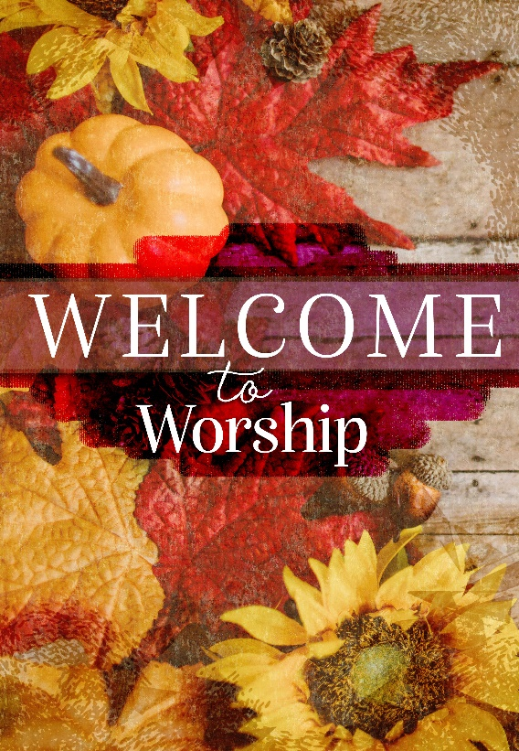

***Our Mission***

*To Lead Everyone in Relationship with Christ.*

***Our Vision***

*Bringing people to Christ; developing personal*

*growth in Christ; putting Christ into action.*