** Upcoming Birthdays**

November 11 – *Dave Bassett, Marian Fuller*

November 22 – *Gladys Foster*

November 23 – *Pat McCormick*

November 27 – *Sue Nelson*

Pastor Karen Sorden

Email: [ksorden@sbcglobal.net](mailto:ksorden@sbcglobal.net)

Phone: 231.282.0433

Prayer Requests (email): umccadillac@gmail.com

Church Website: www.cadillacumc.org

Church Email: umccadillac@gmail.com

Church Mailing Address: PO Box 37, Cadillac, MI 49601

Phone: (231) 775.5362

Office Hours: Monday - Thursday 10:00 a.m. - 4:00 p.m.

Pastor Karen’s Office Hours: Monday – Thursday 9:30 am – 1:00 pm

*Closed on Fridays*

**Volunteer Ministry for Sunday, November 24, 2024**

Organist/Pianist: Cora McLean

Liturgist: Deb DeBruyn

Greeters/Ushers: Margaret Himes, Kay Hinkston, Bob Newland

3 dozen cookies (each) for Coffee Hour: Lark Miller, Diana Detwiler

____________________________________________________________

**CHURCH STAFF**

Pastor: Rev. Karen Sorden

Office Manager: Diane Coon

Treasurer: Sara Adkin

Choir Director: Reg Klubeck

Organists: Ruth Boonzaaijer, Cora McLean, Skip Pluger,

Dr. Glenn Verbrugge

Nursery: Diana VanAntwerp

Custodian: Preston Bruner

**TODAY’S WORSHIP MINISTRY…………….**

Organist/Pianist: Skip Pluger

**Liturgist:** Earl Detwiler

**Greeters/Ushers:** Jerry Deer, Char Butterfield

3 dozen cookies (each) for Coffee Hour: Kay Hinkston, Bev Campbell



**Flowers on the Altar are Given by**

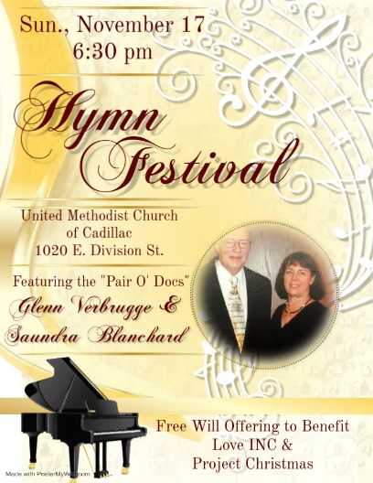**TONIGHT @ 6:30 PM**

Drs. Sandy Blanchard and Glenn Verbrugge (the 'Pair O' Docs') will again lead a **Hymn Festival** with a Concert of Hymn Improvisations and a "Pick-Your- Own" Hymn Sing. An offering will be received for *Love INC* and *Project Christmas*. This is the 27th anniversary for this Musical Event. All are invited and welcome to attend this wonderful evening of music and singing.

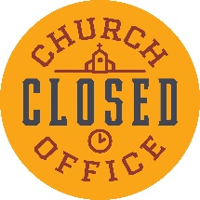 **Note: The church office will be closing at 2:00 p.m. on**

**Tuesday, November 26 and will be closed all day on Wednesday, November 27.** The office will reopen on Monday, December 2 at 10:00 a.m.

The Salvation Army is again hosting **a Thanksgiving Dinner for the community** at Temple Hill Baptist Church on E. Division. I have again committed our church community to supply some pies - 10 pumpkin, 7 cherry and 7 apple. They can be delivered to Temple Hill the Wednesday before or drop them off here and I will see they are delivered. If anyone would like to volunteer at the dinner, please lick on the link below. Thank you for your help. *Dave Bassett*

<https://www.signupgenius.com/go/10C084AA4A82EA2FCC07-45470779-community#/>

**Blessing Bags:** Thank you to those who have already filled and returned a Blessing Bag. Just a friendly reminder: t*he filled bags are requested to be brought back to the church no later than November 24.* You can place your filled bag in front of the altar.

***What’s Happening at Church This Week………***

Sunday, November 17 – 26th Sunday after Pentecost

10:30 a.m. – Worship Service

6:30 p.m. – 27th Hymn Sing Festival Here

Monday, November 18

3:00 p.m. – Prayer Group in Wesley Room

5:00 – 6:00 p.m. – Beginner Guitar Practice w/Gale Butterfield in CR

6:00 – 7:00 p.m. – Intermediate Guitar Practice in Corbin Room

6:00 – 7:30 p.m. – *Single Momm* using Wesley Room & Nursery

7:00 p.m. – BSA Troop #125 Meeting in Fellowship Hall

Tuesday, November 19

7:00 p.m. – CLB Zoom meeting with DS

Wednesday, November 20

10:30 a.m. – 12:30 p.m. – Weight Loss Group in CR

3:30 p.m. – Choir Practice in Sanctuary

5:00 – 7:00 p.m. – Game Night in Fellowship Hall

6:00 – 7:30 p.m. – *Single Momm* using Wesley Room & Nursery

7:00 p.m. – *Alcoholics Anonymous* in Corbin Room

Thursday, November 21

1:30 – 4:30 p.m. – *Wonderland Humane Society* in Classroom #1

3:00 – 5:00 p.m. – *Patriot Choir* in Sanctuary

4:00 – 7:00 p.m. – *Project Christmas* in Fellowship Hall

5:00 – 7:00 p.m. – *4H* in the Kitchen

5:30 – 7:00 p.m. *– Jam & Bread* in Education Wing

Friday, November 22

8:00 p.m. *- Alcoholics Anonymous* in Corbin Room

Sunday, November 24 – Christ the King Sunday

10:30 a.m. – Worship Service